Section VI. Schedule of Requirements

The delivery schedule expressed as weeks/months stipulates hereafter as date of delivery to the project site.

Item Number | Requirements | Quantity | Delivered, Weeks/Months | Statement of Compliance
Period: November 8 – 25, 2021
 | Fabricate a lightweight Mascot for the Philippines participation in Expo 2020 Dubai  Design:  - Create one (1) Ube Boy mascot as per reference artwork below  - Work closely with DTI Expo Team for the specifications and other important details  - Submit appropriate colors swatches of fabrics and sample and accessories (necklace, bracelet, etc.)  Quality and Material:  - Visual Appeal. The Ube Boy artwork should be captured and translated accurately into a lively mascot character.  - Comfort. The ability to easily put on and take off the costume, visibility while wearing the costume, good ventilation, and temperature control options, all contribute to the overall comfort of the mascot. The costume head should include a ventilation system designed to maximize the flow of air inside the mascot. If the mascot will be used outside in a very hot weather, cooling vests should be made available.  - Mobility. The body should provide a good balance and the performer should be able to move freely and easily while wearing the mascot.  - Durability. Mascot should be made up of highest quality materials.  Other requirements:  - Conduct measurements of the performer/s chosen by the Expo Team to wear the costume  - Must be able to provide a user manual and must train the performer/s in terms of wearing, cleaning and repairing the costume  - Must provide appropriate packaging for shipment of the Ube Boy mascot  Image Reference:  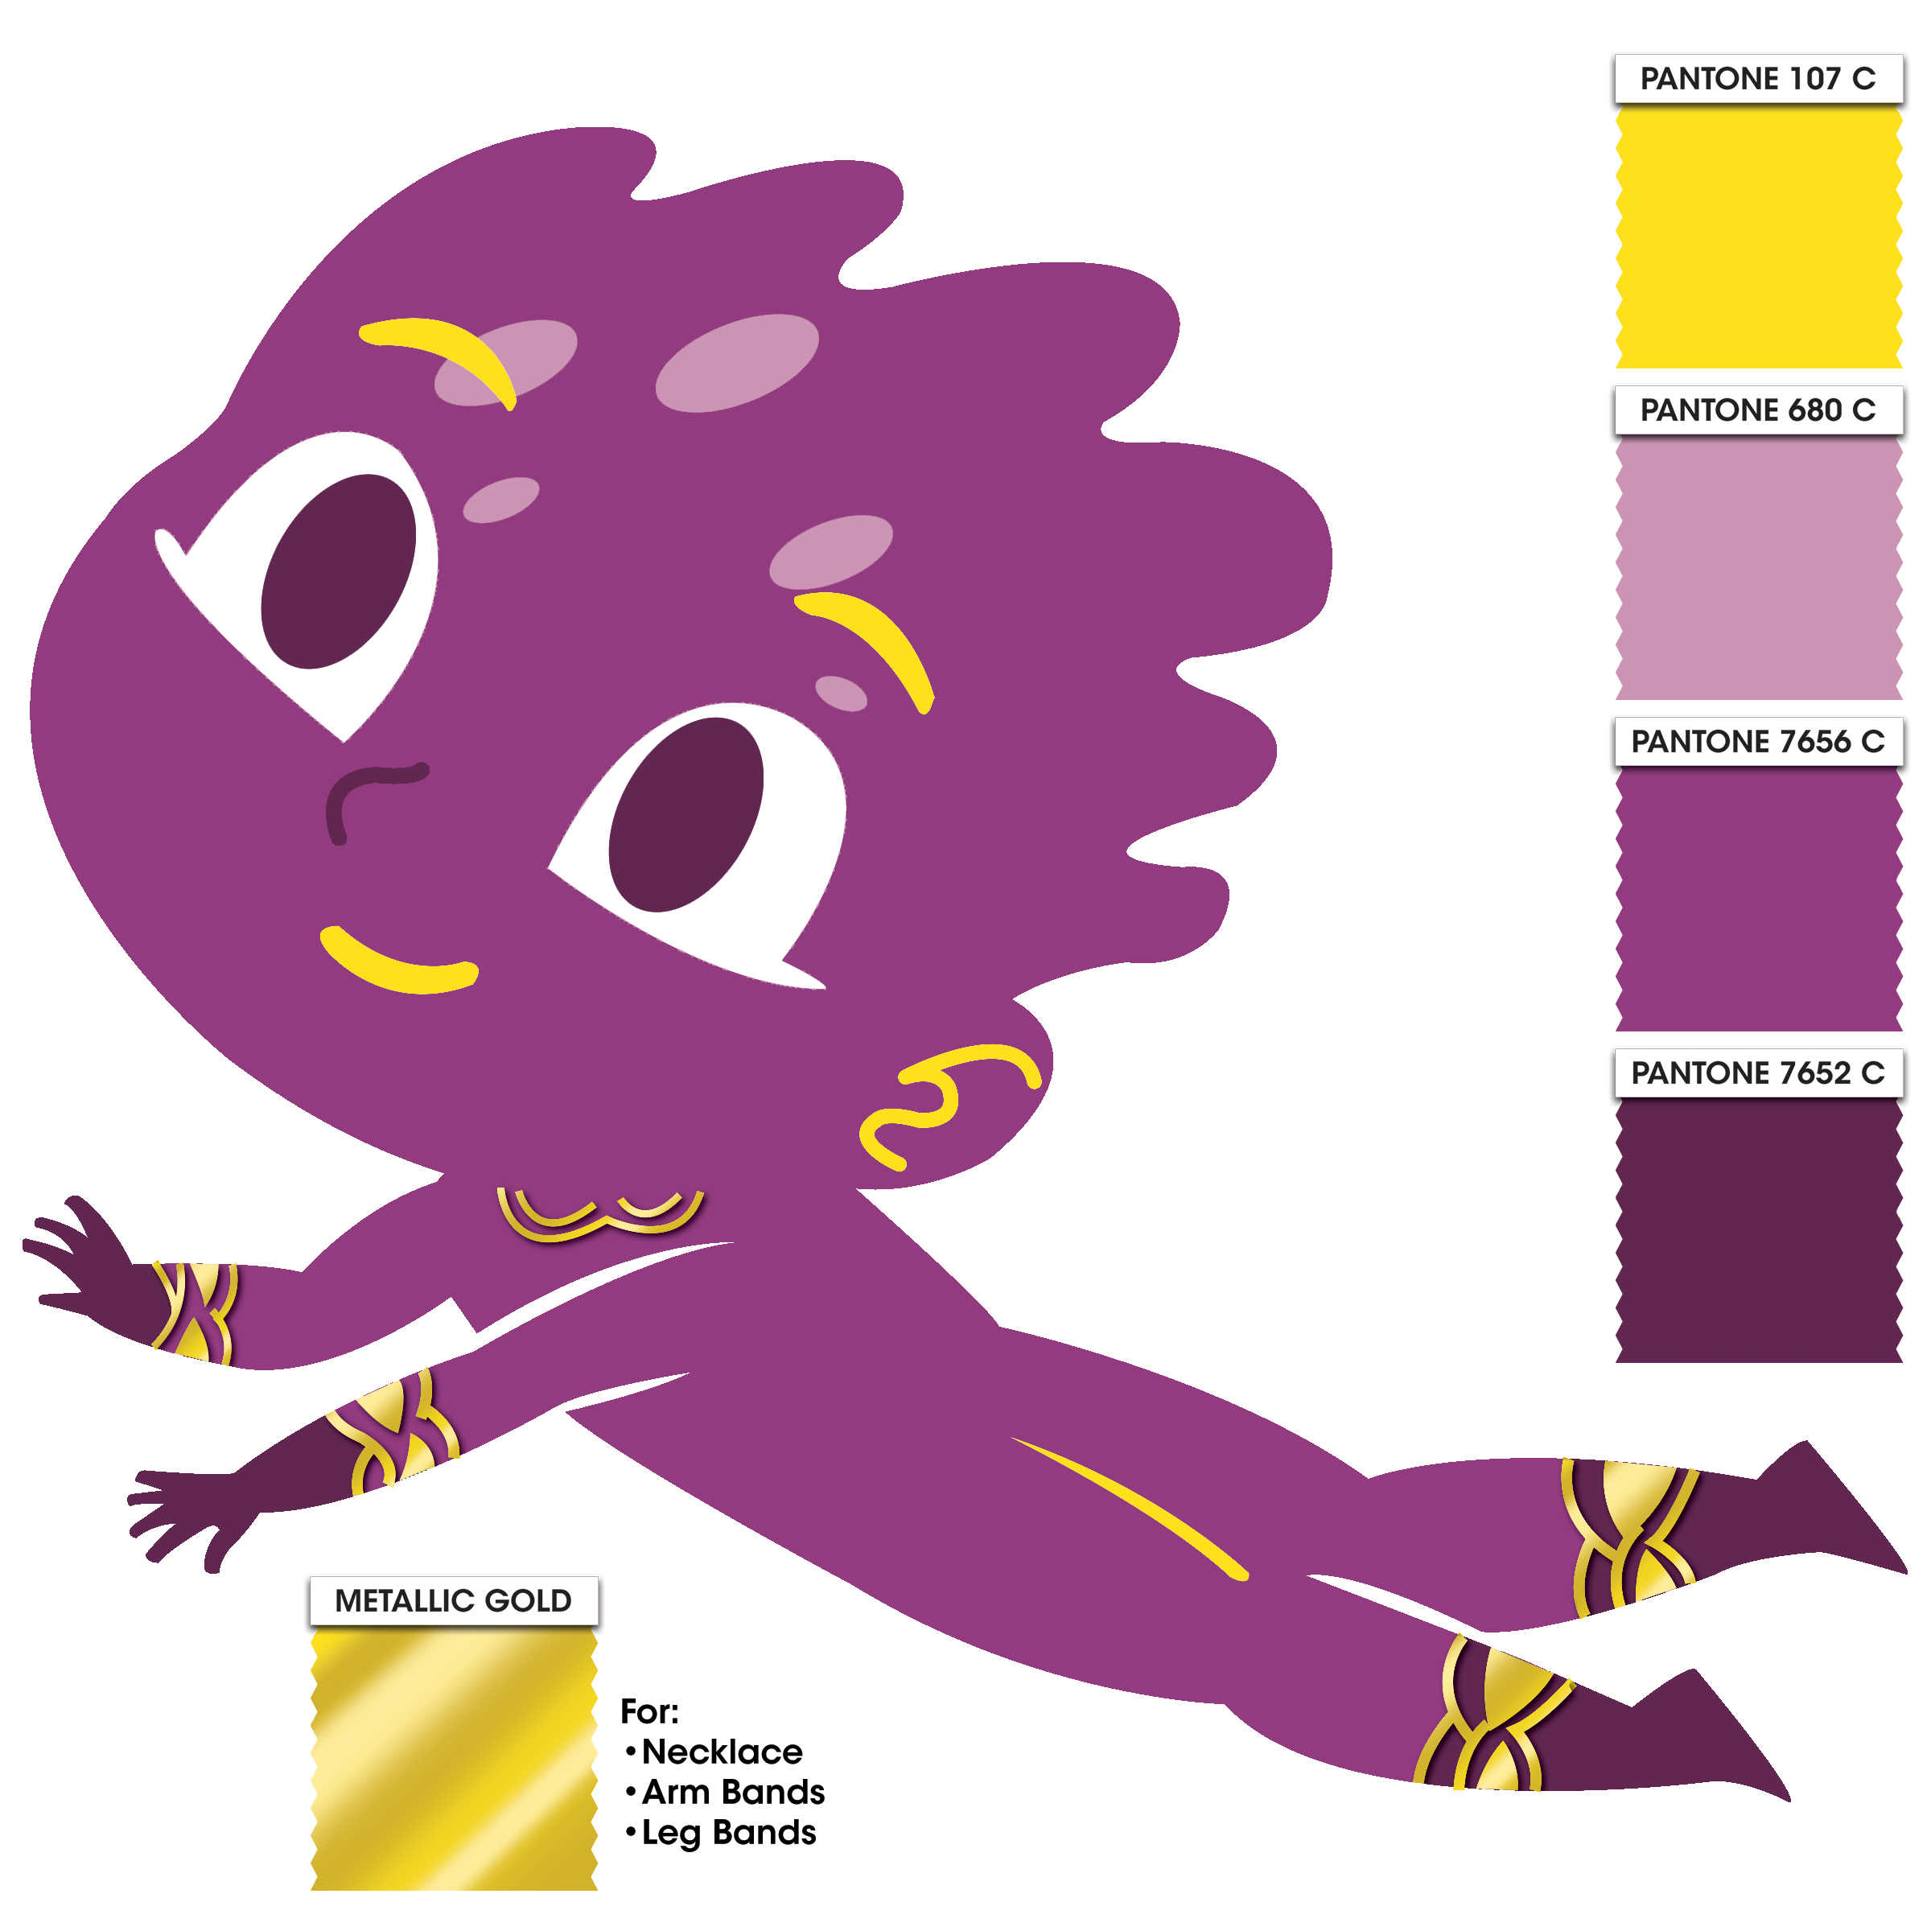  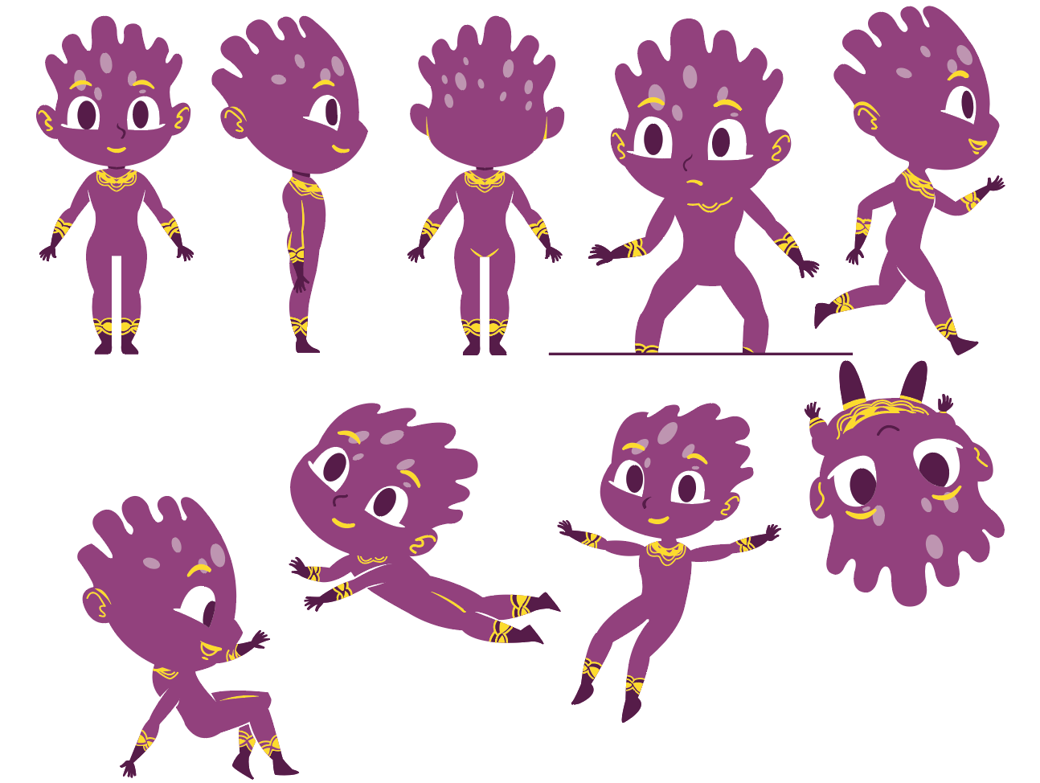  - Head: use lightweight material in fabric finished  - Body/ arms & legs: Foam body with reinforced inner surface with insulator  - Shoes: Foam shoes with soft skin leatherette cover & leather sole skin with fabric finish  - Fabric/s can be faux fur/fleece, antron (muppet) fleece, Bur-fab (Veltrex), poly/cotton twills and heavy-duty spandex or any approve equivalent or material appropriate for mascot skin  - All specifications provided must be followed by the suppliers or approved equivalent must be submitted before commencing works | 1 set

Conforme:
______________________________________
Name & Signature of Authorized Representative
__________________________
Date signed

