Section VII. Technical Specifications
Technical Specifications

Specification | Statement of Compliance
STATE THE COMPLETE TECHNICAL SPECIFICATIONS | [Bidders must state here either “Comply” or “Not Comply” against each of the individual parameters of each Specification stating the corresponding performance parameter of the services and equipment offered. Statements of “Comply” or “Not Comply” must be supported by evidence in a Bidders Bid and cross-referenced to that evidence. Evidence shall be in the form of manufacturer’s un-amended sales literature, unconditional statements of specification and compliance issued by the manufacturer, samples, independent test data etc., as appropriate. A statement that is not supported by evidence or is subsequently found to be contradicted by the evidence presented will render the Bid under evaluation liable for rejection. A statement either in the Bidder's statement of compliance or the supporting evidence that is found to be false either during Bid evaluation, post-qualification or the execution of the Contract may be regarded as fraudulent and render the Bidder or supplier liable for prosecution subject to the applicable laws and issuances.]

OVERSEAS PROCUREMENT OF COSTUME COMPANY TO FABRICATE A LIGHTWEIGHT MASCOT FOR THE
PHILIPPINES PARTICIPATION IN EXPO 2020 DUBAI

TECHNICAL SPECIFICATIONS

INSTRUCTIONS TO THE BIDDER: Indicate “COMPLY” per line number under Bidder’s Statement of Compliance if Bidder can meet the technical specifications and project requirements. DO NOT LEAVE ANY BLANK. A “YES” or “NO” ENTRY WILL NOT BE ACCEPTED. FAILURE TO CONFORM WILL RESULT IN A RATING OF “FAILED”.

# | MINIMUM SPECIFICATIONS | Statement of compliance
1. | Background/ Objective for services being procured
 | The Philippines Participation in Expo 2020 Dubai generated over 100,000 visitors for its first month of its operations and is expecting an increase in visitors by both foreign and local based in Dubai, due to the incoming winter season and easing the travel restrictions worldwide.  As we are one of the most visited pavilions within the Jubilee district and we are organizing more activation within the Philippines pavilion in the next 5 months of the EXPO duration for our countrymen and all the visitors enjoying their experience at the Bangkota, the office of the Assistant Secretary, Trade Promotion Group, concurrent Alternate Commissioner General of the Philippines Expo 2020 Dubai would like to establish a distinct and recognizable brand personality representing the Philippines Pavilion in Expo 2020 Dubai. It will be one of the key promotional marketing tools that will likewise be used to entertain and engage the visitors.  The Ube boy mascot is the “avatar” of the Philippines Pavilion and is needed to be light weight to be able to move freely and dance during the various events and activities. Having the 3rd Ube boy Mascot will let the visitors be more engage to different areas within the Philippines pavilion from Plaza to Imaginarium area. Having a 3,163,25 sq.m. plot size, there is a need to increase the visibility of Ube boy with the Philippines Pavilion and Expo 2020 Dubai.  - To establish a distinct and recognizable brand personality representing the Philippines Pavilion in Expo 2020 Dubai  - To create mascot as the “avatar” of the Philippines Pavilion in a light weight material to be able to move freely, dance, and interact with the visitors during various events and activities with the pavilion  - To increase the visibility of Ube boy within the Expo 2020 Dubai as the avatar of Philippines and to promote Philippines participation in Expo 2020 Dubai | COMPLY
2. | TECHNICAL ELIGIBILITY
 | - Must be operated and legally registered Costume Company (LC) in the UAE.  - Must have a track record of providing mascot and costumes f and services for 5 years or more  - Must be willing to adhere to the Payment Terms of the Philippine Government | COMPLY
3. | TECHNICAL DOCUMENTS TO BE SUBMITTED BY TENDERER
 | - Copy of Trade License with validity/ date issued by a UAE Municipality  - Company Profile  - TRN Certification/ Registration or approved equivalent documents | COMPLY
4. | SCOPE OF WORK
 | The Costume Company shall provide the requirements based on the specifications provided. | COMPLY
 | Design:  Create one (1) Ube Boy mascot as per reference artwork below | COMPLY
 | Work closely with DTI Expo Team for the specifications and other important details | COMPLY
 | Submit appropriate colors swatches of fabrics and sample and accessories (necklace, bracelet, etc.) | COMPLY
 | Quality and Material  Visual Appeal. The Ube Boy artwork should be captured and translated accurately into a lively mascot character. | COMPLY
 | Comfort. The ability to easily put on and take off the costume, visibility while wearing the costume, good ventilation, and temperature control options, all contribute to the overall comfort of the mascot. The costume head should include a ventilation system designed to maximize the flow of air inside the mascot. If the mascot will be used outside in a very hot weather, cooling vests should be made available. | COMPLY
 | Mobility. The body should provide a good balance and the performer should be able to move freely and easily while wearing the mascot. | COMPLY
 | Durability. Mascot should be made up of highest quality materials. | COMPLY
 | Other Requirements  Conduct measurements of the performer/s chosen by the Expo Team to wear the costume | COMPLY
 | Must be able to provide a user manual and must train the performer/s in terms of wearing, cleaning and repairing the costume | COMPLY
 | Must provide appropriate packaging for shipment of the Ube Boy mascot | COMPLY
 | Image Reference:  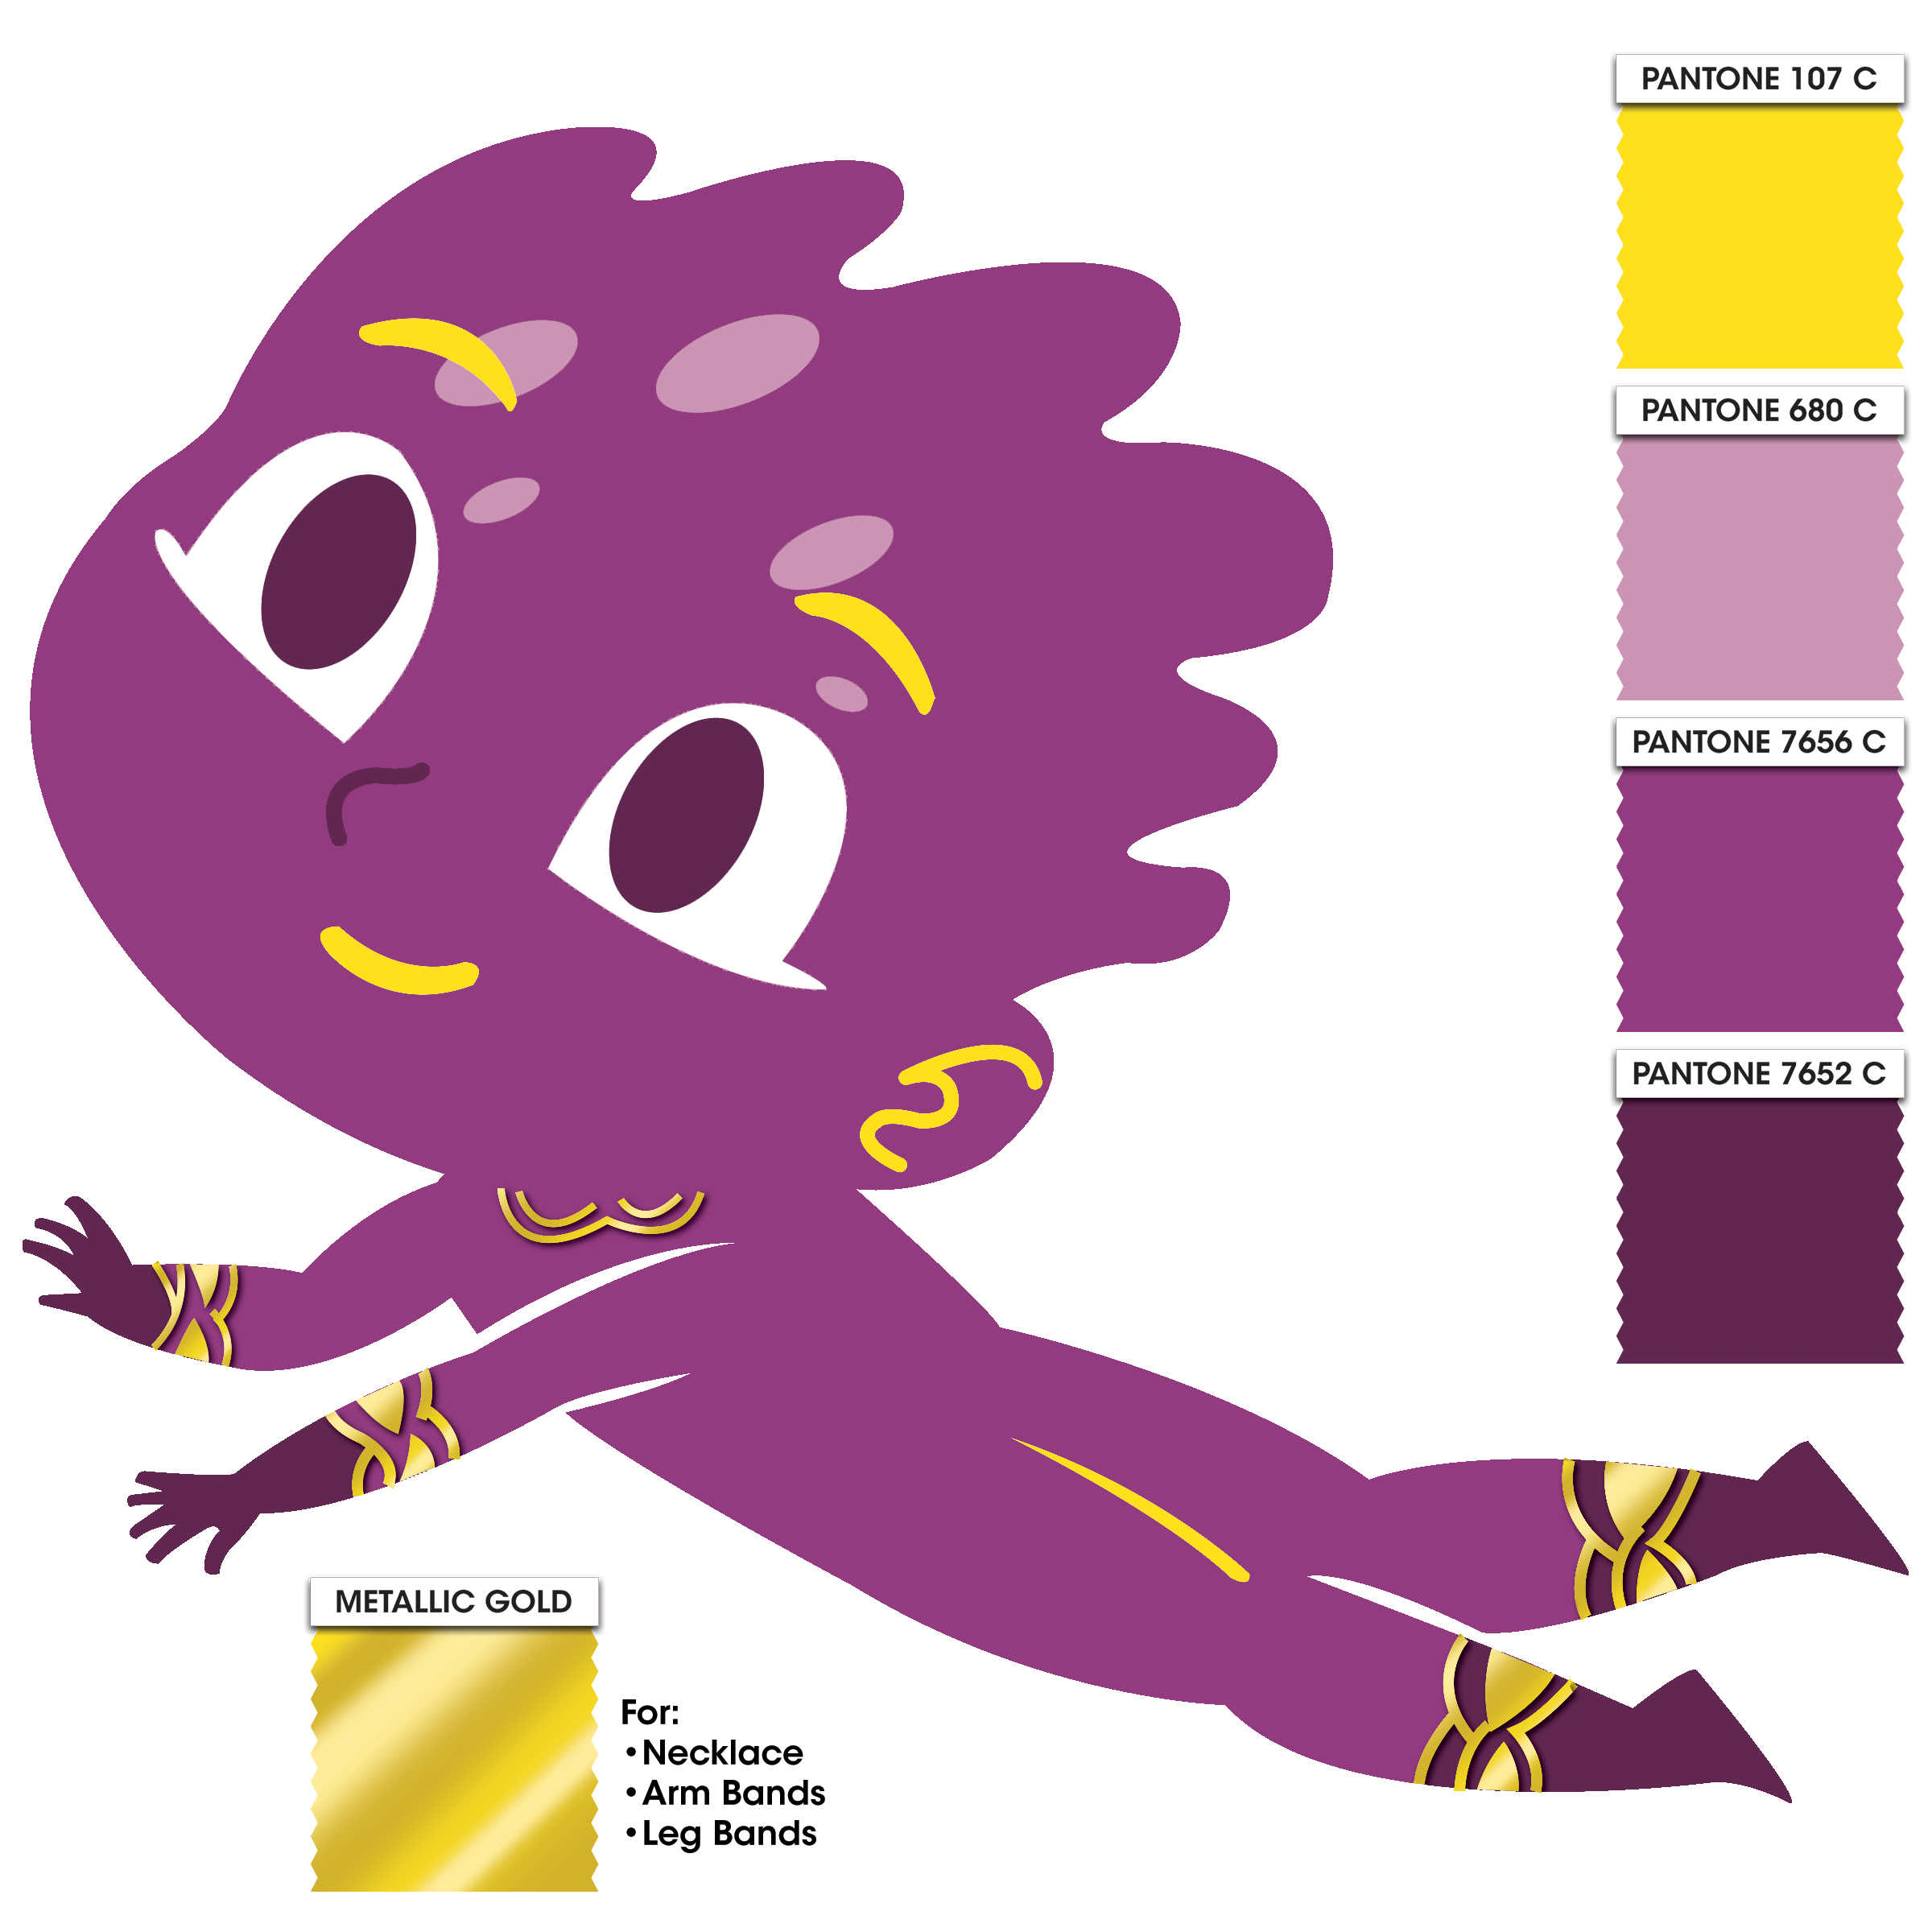  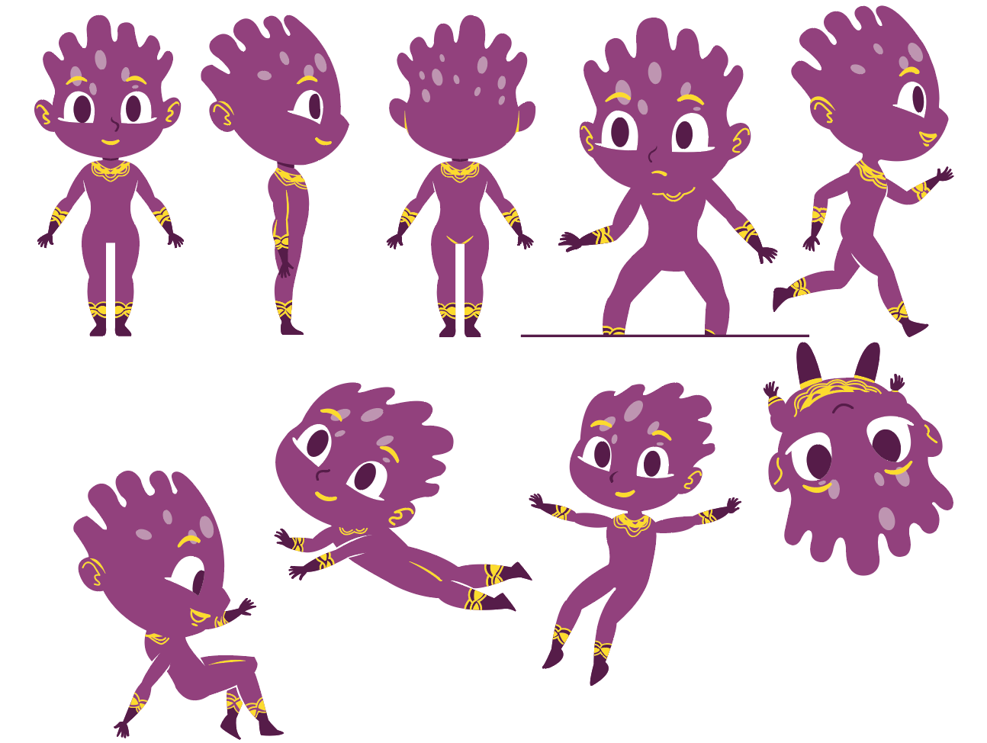 | COMPLY
 | Head: use lightweight material in fabric finished | COMPLY
 | Body/ arms & legs: Foam body with reinforced inner surface with insulator | COMPLY
 | Shoes: Foam shoes with soft skin leatherette cover & leather sole skin with fabric finish | COMPLY
 | Fabric/s can be faux fur/fleece, antron (muppet) fleece, Bur-fab (Veltrex), poly/cotton twills and heavy-duty spandex or any approve equivalent or material appropriate for mascot skin | COMPLY
 | All specifications provided must be followed by the suppliers or approved equivalent must be submitted before commencing works | COMPLY
5. | SCHEDULE OF WORK
 | November 8 – 25, 2021  Approval of material sample, purchasing of materials, fabrication and delivery | COMPLY
 | November 25, 2021  100% work completed | COMPLY
6. | BUDGET AND TERMS OF PAYMENT
 | Approved budget for the contract (ABC) is AED or PHP 120,000.00 inclusive of all applicable taxes in UAE upon delivery of completed requirement. The winning bidder shall be determined based on the quality of proposal with the most advantageous financial package cost, provided that the amount of bid does not exceed the ABC. | COMPLY
 | Invoice and payment must be issued/ payable to the Republic of the Philippines Pavilion – Expo 2020 with license no. EXP – 01 – 46. | COMPLY
 | Payment schedule will be as follows:  1st Payment (15%): PHP 18,000.00 / AED 1,285.65  Initial Payment  Processing of payment upon submission of drawings with mascot sizing per body parts based on the users body measurement | COMPLY
 | 2nd Payment (35%): PHP 42,000.00 / AED 2,999.85  Progress Payment  Processing of payment upon submission of material swatches for approval | COMPLY
 | 3rd Payment (50%): PHP 60,000.00 / AED 4,285.50  Final Payment  Processing of payment upon submission of Delivery Receipt and request for final payment | COMPLY

I hereby certify that the statement of compliance to the foregoing technical specifications are true and correct, otherwise, if found to be false either during bid evaluation or post-qualifications, the same shall give rise to automatic disqualification of our bid.

Name of Company:
Signature:
Signature Over Printed Name of Authorized Representative
Date:

Conforme:

______________________________________
Name & Signature of Authorized Representative

__________________________
Date signed

