Section VI. Schedule of Requirements

The delivery schedule expressed as weeks/months stipulates hereafter as date of delivery to the project site.

Item Number | Requirements | Quantity | Delivered, Weeks/Months | Statement of Compliance
Period: November to December 31, 2021
- Digital Interactive Enhancements
Item Number | Requirements | Qty | Description | Locations | Delivered, Weeks/ Months | Statement of Compliance
 | Premium Locking Floor Stand Kiosk for iPad  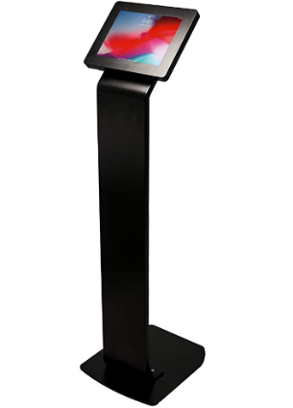  (see below for photo reference) | 8 pcs. | Color: Black  Material: Alloy Steel / Durable Steel Body  Heavy-duty locking enclosure  Enclosure rotates 360°, Easily adjusting for horizontal and vertical views  Provides full access to camera, home button and charging socket  Fits iPad-2019 (7th generation) 10.2 inch  Provision for charging station and wiring organization if there will be a need to charge inside the Pavilion’s exhibit spaces  Height may be adjustable depending on the recommendation of supplier | 2 pcs at Area 2A- Nature is Peace  2 pcs at Area 2B- Man is Nature  2 pc at Variety of the World  2 pcs. at the Our Gift to the World
 | 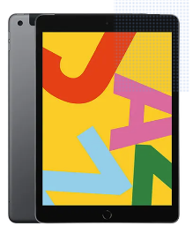  iPad-2019 | 8 pcs. | iPad-2019 (7th Generation) 10.2inch, 64GB, Wi-Fi, Space Gray/ Black  Complete with Charger with applicable wiring and accessories  Display Resolution: 2160x1620 pixel  For Rental | -do-
 | 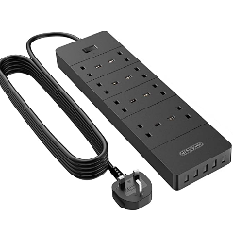  2-3 Meter Extension Cord | 4 pcs. | 2-3 Meter Extension Cord  3250W Power Strip,  1700J Surge Protector  Extension Lead with 4 AC socket, 13amp Fused UK Plug | -do-
- All specifications provided must be followed by the suppliers or approved equivalent must be submitted before commencing and installation
- All items are on rental basis

- Stage and Audience
 | Item | Qty | Description | Locations | Delivered, Weeks/ Months | Statement of Compliance
 | Movable Stage Platform/ Stage System  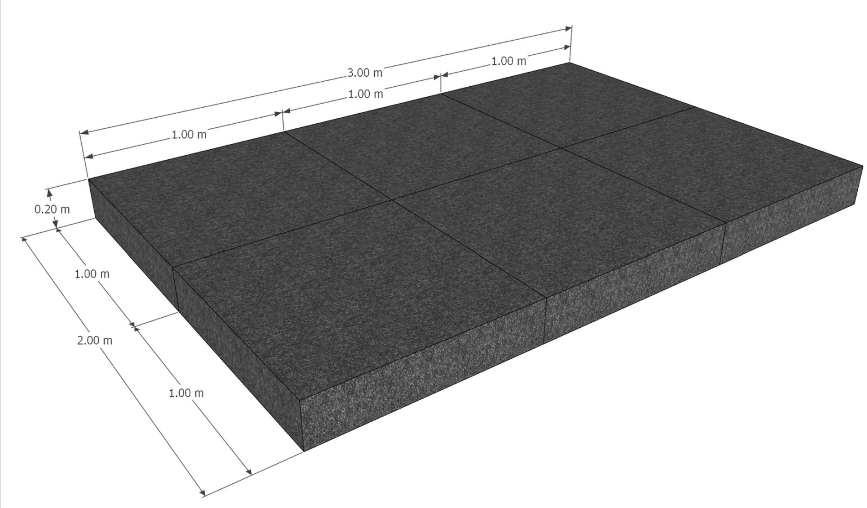 | 6 pcs. | Size: 1.0 x 1.0 m  Height: .2 m  Surface: weatherproof 12 mm blockboard with HEXA anti-slip coating  - Dimensions: 1.0 x 1.0 m  Max. Load capacity: 250 kg at 1.0 x 0.5 m  - Weight: 8 kg (without feet)  - Surface colour: black  Should include folding leg for stage platforms with click function  With heavy-duty caster wheels with lock | Imaginarium Decks, Deck 1, Deck 2, Roofdeck
 | Projection Screen  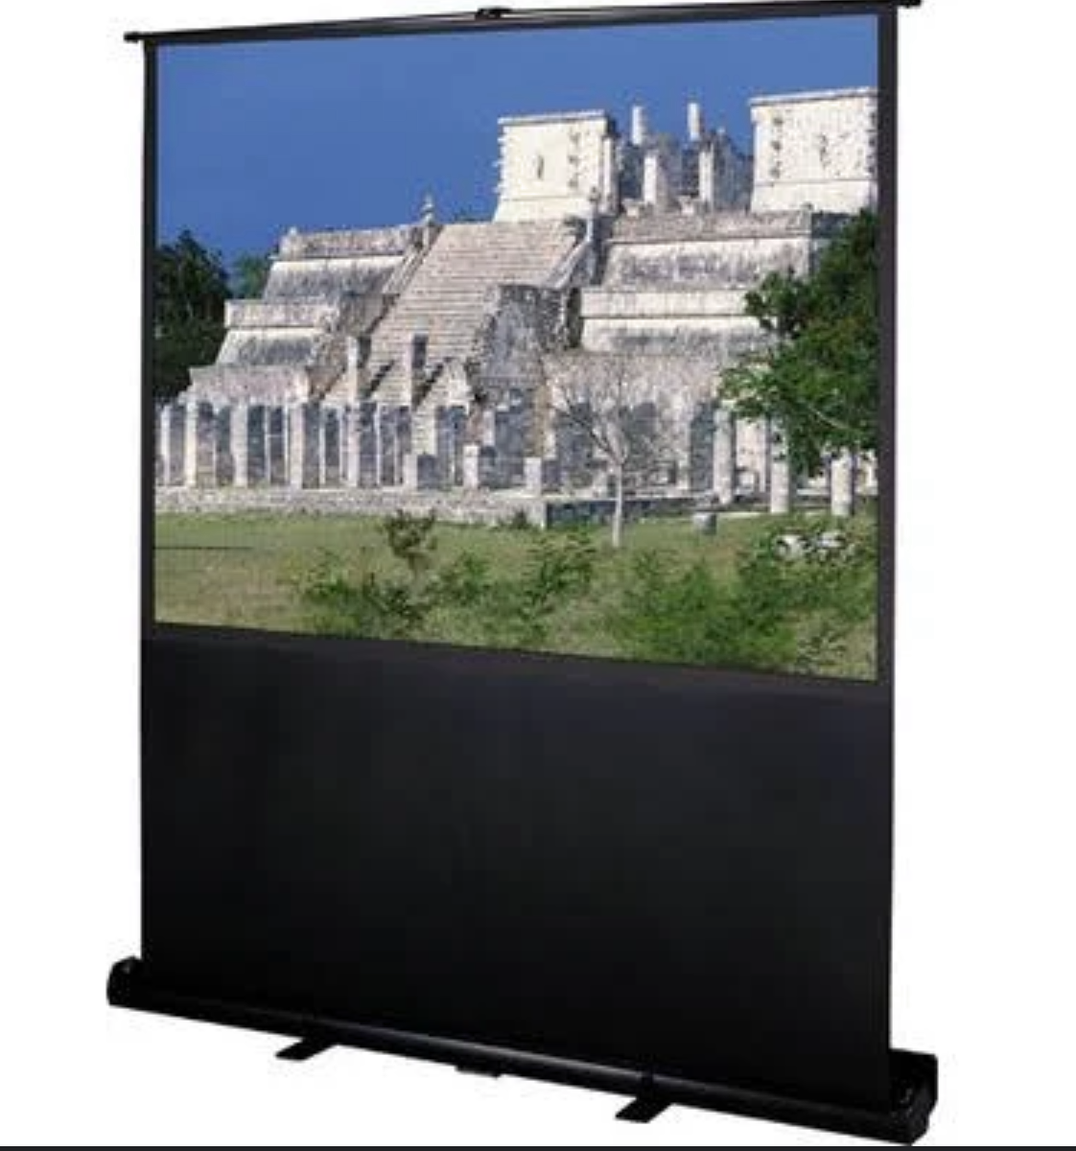 | 1 pc | Theatre portable projection screen (100 inch)  Tension Control: Pneumatic scissor mechanism – easily raise and lower the screen
 | 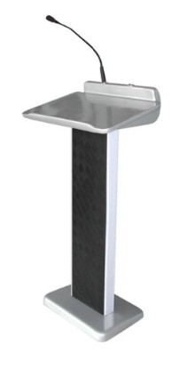  Rostrum | 1 pc. | Rostrum  Refer to sample photo  Subject to proposal of bidder | -do-
- All specifications provided must be followed by the suppliers or approved equivalent must be submitted before commencing and installation
- All items are on rental basis

- Public Address and Projection System for Pocket Events
 | Item | Qty | Description | Delivered, Weeks/ Months | Statement of Compliance
 | Portable Public Access (PA) System  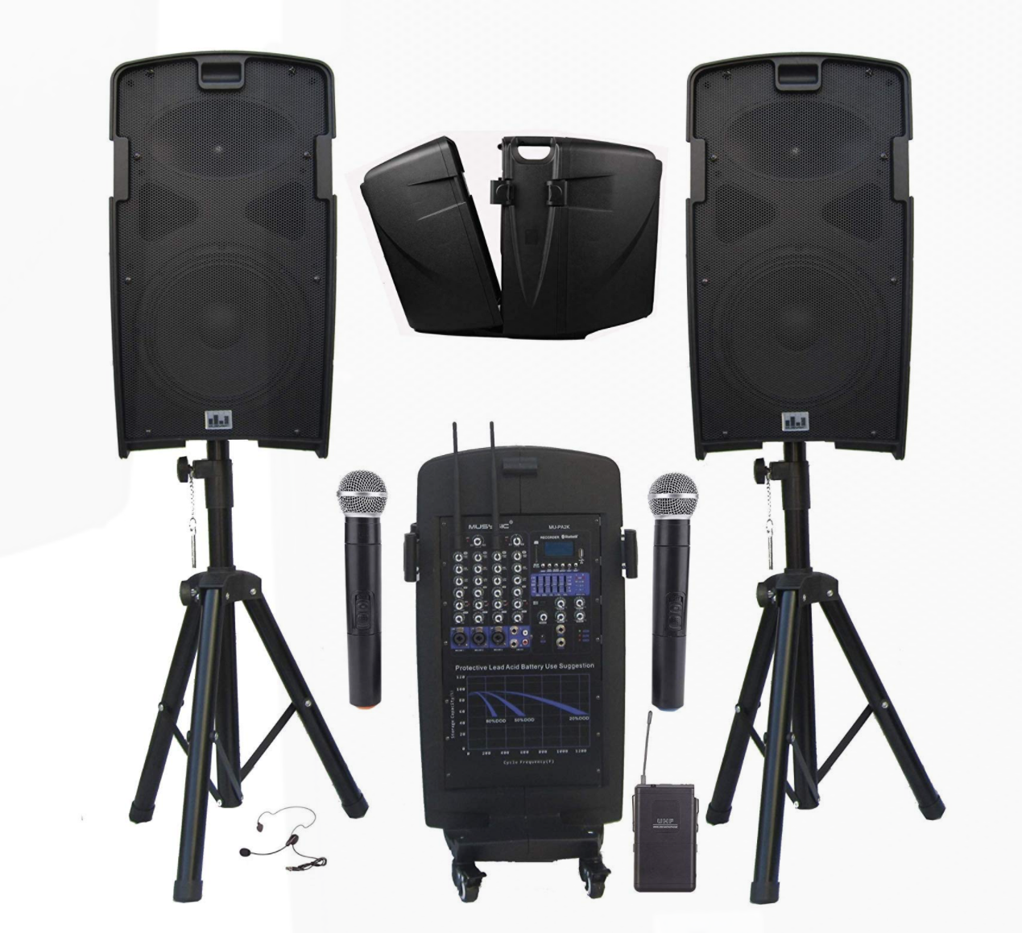 | 1 set | - Professional 2000 Watts Portable PA System  - 5 Channel Mixer with Built-in Class-D Amplifier  - Built-in Dual UHF Wireless Microphone System, Rechargeable Battery, Cables & Speaker Stands.  - 2000 watts PMPO - ample for medium to large audiences / Integrated 5-channel mixer lets you intuitively mix lecture panels, musical ensembles and more /.  - Bluetooth Function, USB/SD Card Slot (Record, Play/Pause, Previous Track, Next Track)  - Built-in Rechargeable Battery (4-5 hours of uninterrupted sound on full charge), Speaker stands, Wheels for easy moving.  - Rechargeable battery- great for both  indoor/outdoor events when there is no external power source  available (tested to provide 4-5 hours of uninterrupted sound on  full charge). System work with Plug-in power cord and also with  Rechargeable battery  - With simple and easy setup/breakdown process of the system and allows  for easy transportation
 | Microphone Stands  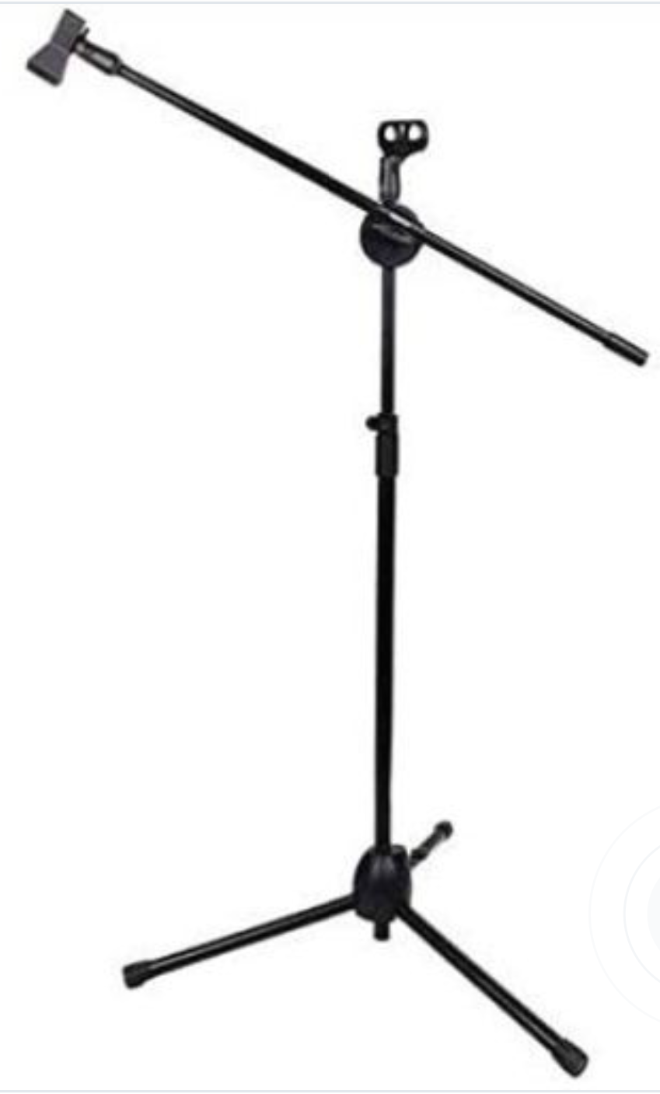 | 2 pcs | - Metallic Tripods Holder Telescopic Floor Boom Stand  - Powder-Coated finish and scratch resistant
 | Pro Portable Projector for Outdoor  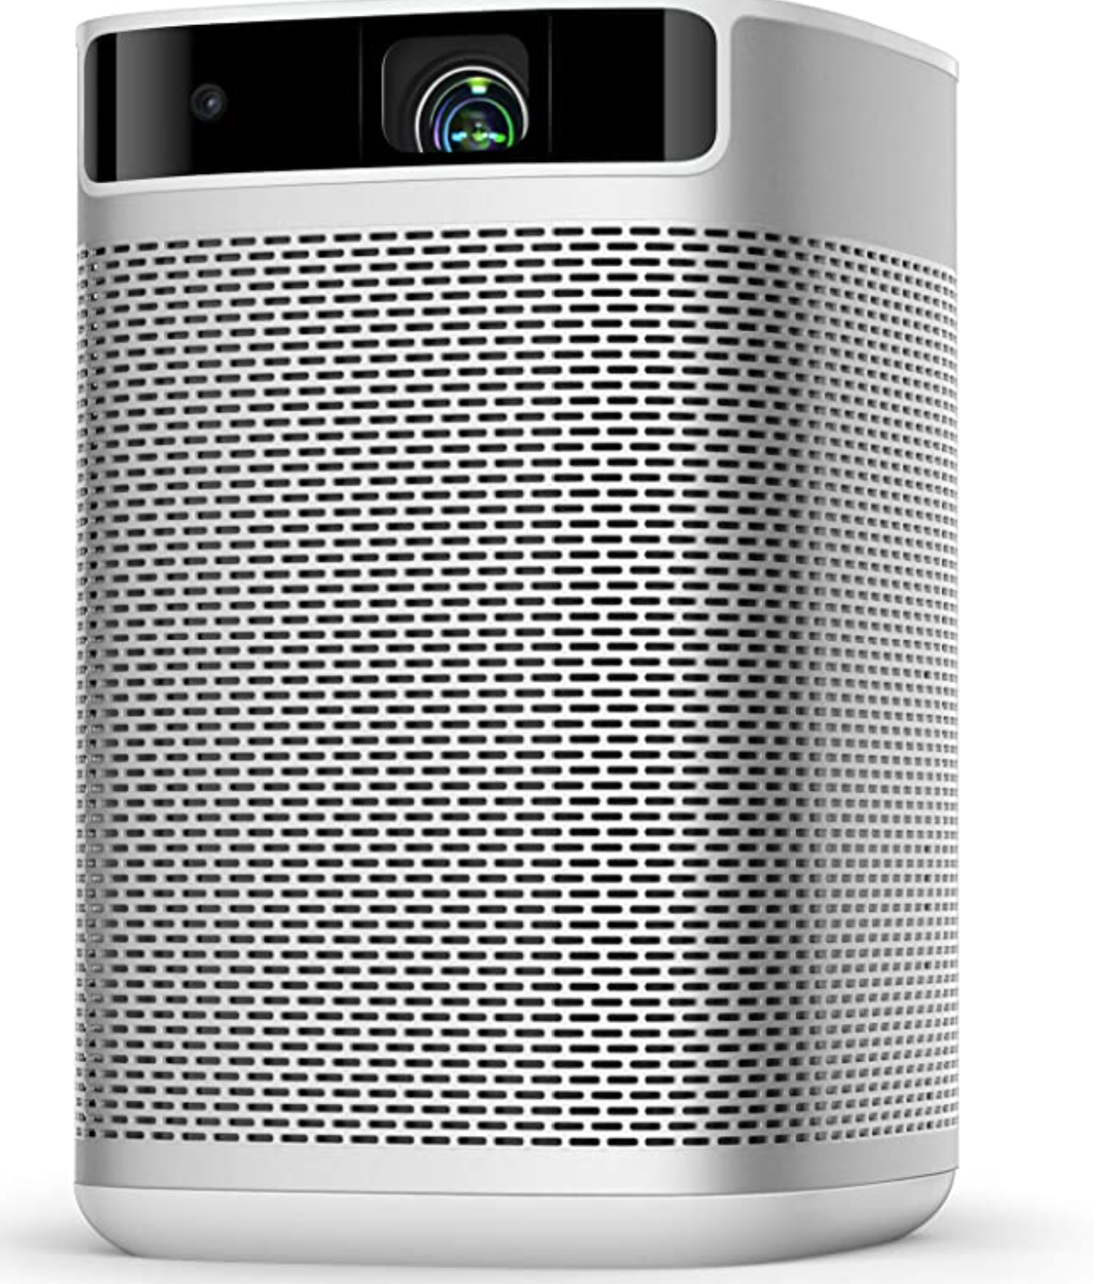 | 1 pc | - Pro Portable Projector for Outdoor projection  - 1080 P Image with 300 ANSI Lumens  - Smart Projector with Keystone Correction  - WiFi Bluetooth  - Android TV 9.0 5000  - With HDMI port, USB 2.0 ports  - Battery powered  - Average Battery Life (> 3.5 hrs)
 | Portable Power Source  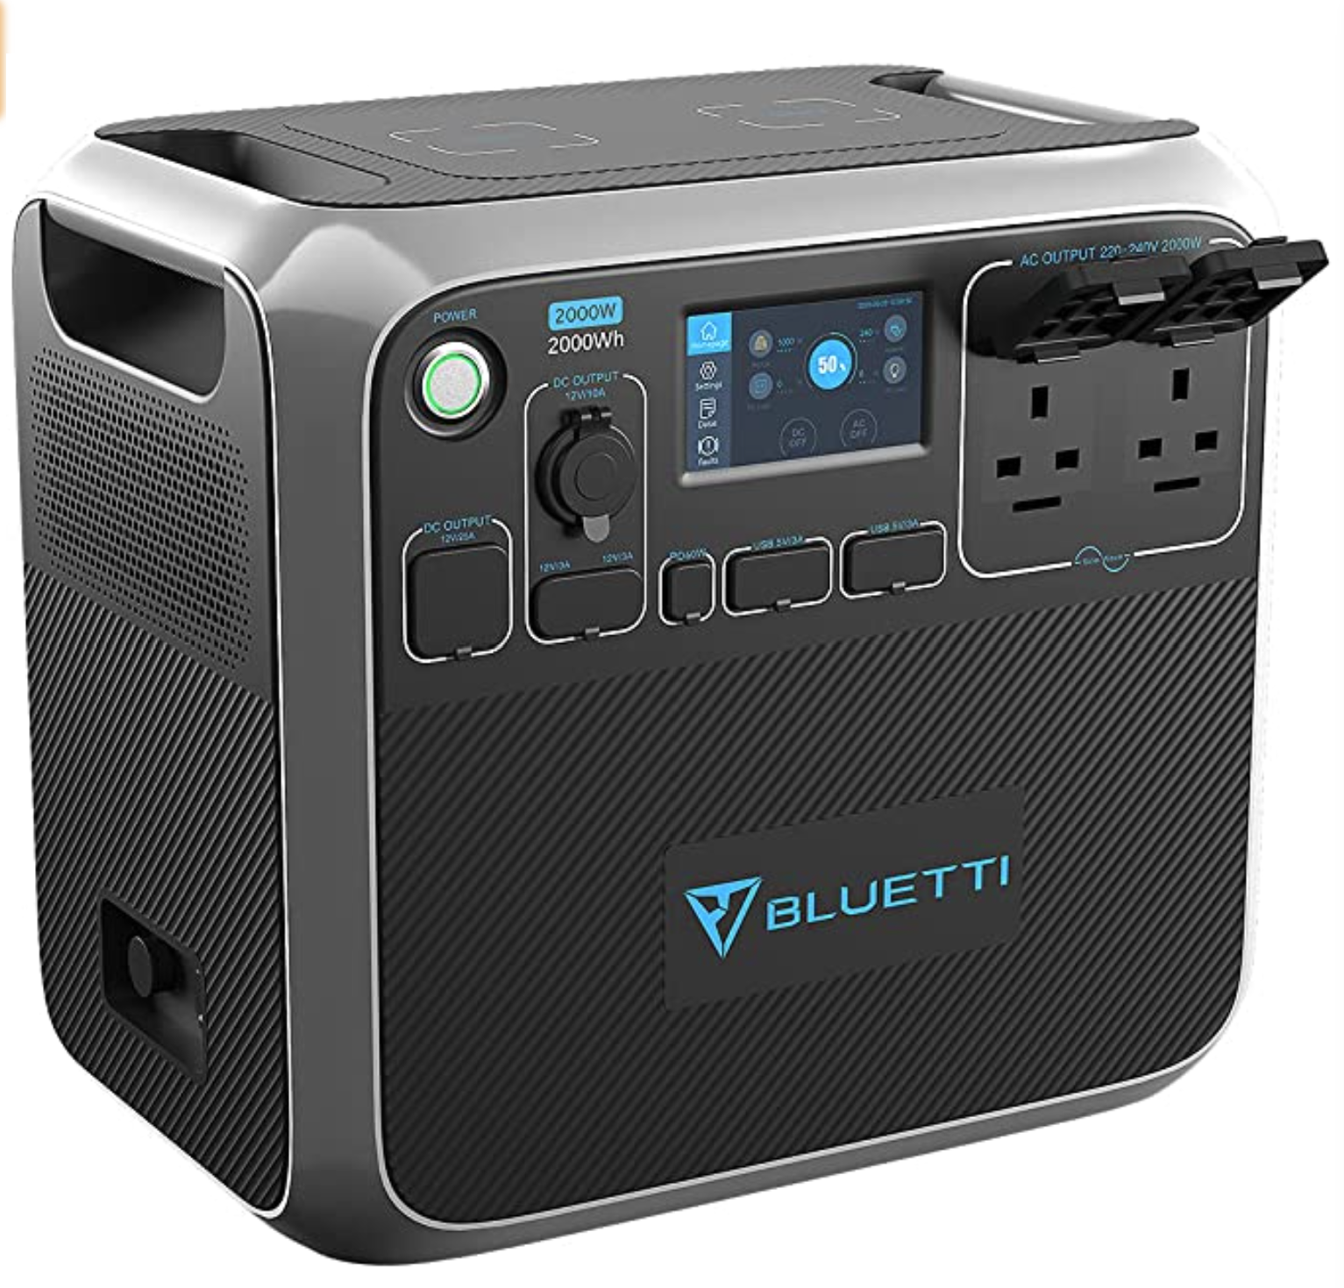 | 1 pc | - Portable Power Generator 2000Wh  - Solar Power Station Lithium Battery Power Supply with LED Flashlights  - Weight: 3.06 kg  - A wide range of output options:  - 2*AC outlets, 1*12V/25A RV port, 2*15W wireless pad, 1* PD 60W USB-C, 4* USB-A, 1*12V/10A car port and 2* 12V/3A  - With built-in advanced system control circuit module
 | Laptop Audio Connection  Cables and Accessories | 1 set
- All specifications provided must be followed by the suppliers or approved equivalent must be submitted before commencing and installation
- All items are on rental basis

Conforme:
______________________________________
Name & Signature of Authorized Representative
__________________________
Date signed

