Section VI. Schedule of Requirements

The delivery schedule expressed as weeks/months stipulates hereafter as date of delivery to the project site.

Item Number | Requirements | Quantity | Delivered, Weeks/Months | Statement of Compliance
Period: November to December 31, 2021
- Digital Interactive Enhancements
Item Number | Requirements | Qty | Description | Locations | Delivered, Weeks/ Months | Statement of Compliance
 | Premium Locking Floor Stand Kiosk for iPad  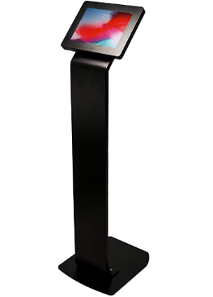  (see below for photo reference) | 6 pcs. | Color: Black  Material: Alloy Steel / Durable Steel Body  Heavy-duty locking enclosure  Enclosure rotates 360°, Easily adjusting for horizontal and vertical views  Provides full access to camera, home button and charging socket  Fits iPad-2019 (7th generation) 10.2 inch  Provision for charging station and wiring organization if there will be a need to charge inside the Pavilion’s exhibit spaces  Height may be adjustable depending on the recommendation of supplier | 2 pcs at Area 2A- Nature is Peace  1 pcs at Area 2B- Man is Nature  1 pc at Variety of the World  2 pcs. at the Our Gift to the World
 | 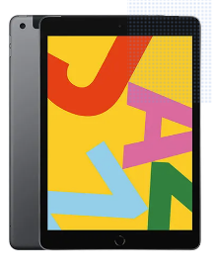  iPad-2019 | 6 pcs. | iPad-2019 (7th Generation) 10.2inch, 64GB, Wi-Fi, Space Gray/ Black  Complete with Charger with applicable wiring and accessories  Display Resolution: 2160x1620 pixel  For Rental | -do-
 | 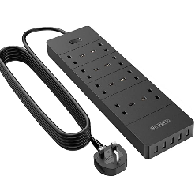  2-3 Meter Extension Cord | 4 pcs. | 2-3 Meter Extension Cord  3250W Power Strip,  1700J Surge Protector  Extension Lead with 4 AC socket, 13amp Fused UK Plug | -do-
- All specifications provided must be followed by the suppliers or approved equivalent must be submitted before commencing and installation
- All items are on rental basis

- Stage and Audience
 |  | Item |  | Qty | Description | Locations | Delivered, Weeks/ Months | Statement of Compliance
 |  | Movable Stage Platform/ Stage System  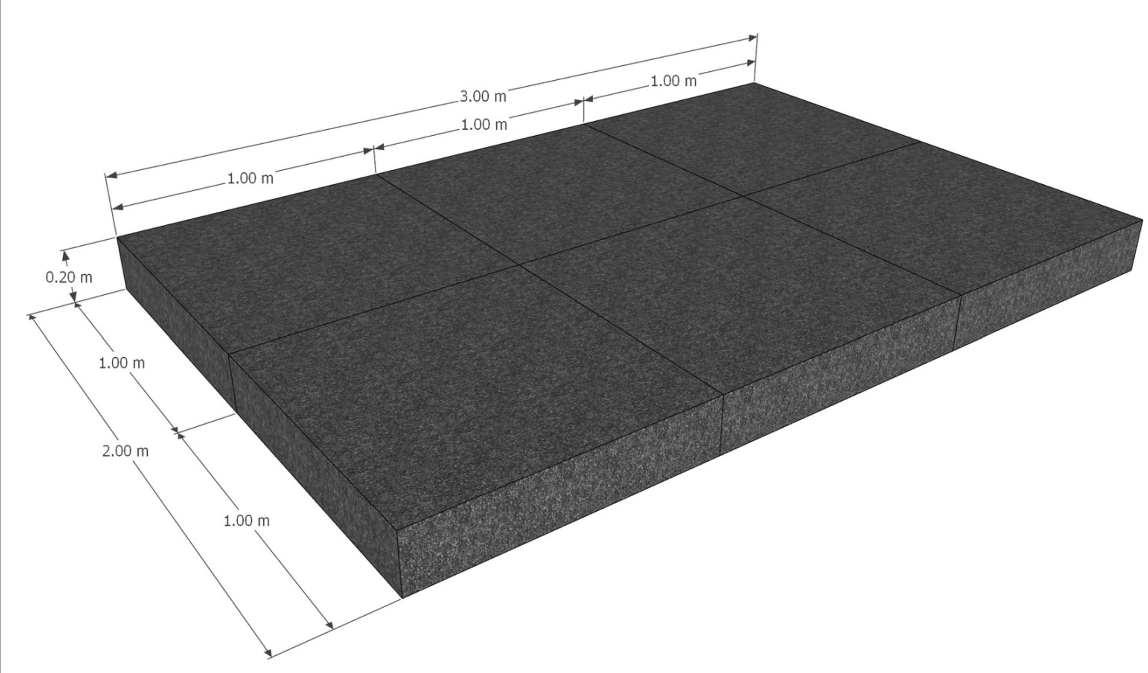 |  | 1 lot | Size: 1.0 x 1.0 m  Height: .2 m  Surface: weatherproof 12 mm blockboard with HEXA anti-slip coating  - Dimensions: 1.0 x 1.0 m  Max. Load capacity: 250 kg at 1.0 x 0.5 m  - Weight: 8 kg (without feet)  - Surface colour: black  Should include folding leg for stage platforms with click function  With heavy-duty caster wheels with lock | Imaginarium Decks, Deck 1, Deck 2, Roofdeck
 |  | Workshop Tables  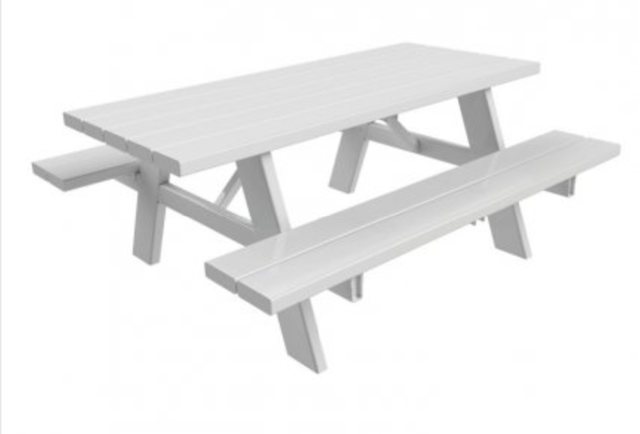 |  | 4 pcs. | Custom made 3 pc wooden picnic table for outdoor use - collapsible  Can be used for indoor and outdoor set-up  Table Size (in cm):  85x150x75 (WxLxH)  Bench Size (in cm):  30x150x44 (WxLxH)
 |  | 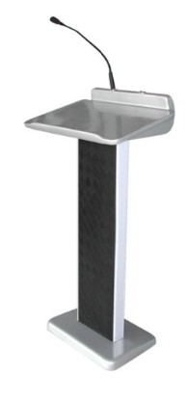  Rostrum |  | 1 pc. | Rostrum  Refer to sample photo  Subject to proposal of bidder | -do-
- All specifications provided must be followed by the suppliers or approved equivalent must be submitted before commencing and installation
- All items are on rental basis

Conforme:
______________________________________
Name & Signature of Authorized Representative
__________________________
Date signed

