Section VII. Technical Specifications
Technical Specifications

Specification | Statement of Compliance
STATE THE COMPLETE TECHNICAL SPECIFICATIONS | [Bidders must state here either “Comply” or “Not Comply” against each of the individual parameters of each Specification stating the corresponding performance parameter of the services and equipment offered. Statements of “Comply” or “Not Comply” must be supported by evidence in a Bidders Bid and cross-referenced to that evidence. Evidence shall be in the form of manufacturer’s un-amended sales literature, unconditional statements of specification and compliance issued by the manufacturer, samples, independent test data etc., as appropriate. A statement that is not supported by evidence or is subsequently found to be contradicted by the evidence presented will render the Bid under evaluation liable for rejection. A statement either in the Bidder's statement of compliance or the supporting evidence that is found to be false either during Bid evaluation, post-qualification or the execution of the Contract may be regarded as fraudulent and render the Bidder or supplier liable for prosecution subject to the applicable laws and issuances.]

For Overseas Procurement – Provision, Installation, Delivery, and Set-Up of
Exhibition Services
for the Digital Interactive Enhancements and Activations
at the Philippines Pavilion at Expo 2020 Dubai

TECHNICAL SPECIFICATIONS

INSTRUCTIONS TO THE BIDDER: Indicate “COMPLY” per line number under Bidder’s Statement of Compliance if Bidder can meet the technical specifications and project requirements. DO NOT LEAVE ANY BLANK. A “YES” or “NO” ENTRY WILL NOT BE ACCEPTED. FAILURE TO CONFORM WILL RESULT IN A RATING OF “FAILED”.

# | MINIMUM SPECIFICATIONS |  |  |  |  |  | Statement of compliance
1. | Background/ Objective for services being procured
The Philippines Participation in Expo 2020 Dubai has generated over 100,000 visitors for its first month of its operations and is expecting an increase in visitors by both foreign and local based in Dubai, due to the incoming winter season and the easing of travel restrictions worldwide.

The Philippines Expo Secretariat conducted market scanning and initiated group discussions with avid visitors, vloggers/bloggers and content strategists to talk about actionable improvements that can be done in the Pavilion.

As a result of these consultative meetings, the Philippines Pavilion Secretariat decided to stage more activations to enliven the Pavilion grounds and implement digital immersive enhancements in certain areas to promote the use of Bangkota’s digital platforms such as the Bangkota Trivia Quest (Game Application) and Bangkota Mobile Visitor App (Virtual Tour Guide).

Therefore, there is a need to conduct overseas procurement for the provision, installation, delivery, and set-up of exhibition services for the digital interactive enhancements and activations at the Philippines Pavilion at Expo 2020 Dubai.

Objective:
- To improve the overall interactivity at the Philippines Pavilion
- To increase visitor engagement through the promotion of the Philippines Bangkota application: Bangkota Trivia Quest (Game Application) and Bangkota Mobile Visitor App (Virtual Tour Guide)

2. | ELIGIBILITY REQUIREMENTS
- VAT Registration in UAE
- Company Profile
- Business License to Operate in the UAE
- Tax Clearance (or its equivalent in UAE)

3. | TECHNICAL SPECIFICATIONS/ SCOPE OF WORK
 | Bidders for this overseas procurement request must be based in Dubai, United Arab Emirates and can deliver the requirements on urgent basis following the Philippine Government Procurement rules and regulations or per RA 9184.
 | The Bidder will provide, set-up and install the following equipment on lease from the date of awarding until 31 December 2021;
 | The Bidder would provide the basic maintenance and services to the equipment at no extra cost as and when required by Client;
 | The rental agreement may be terminated by either parties provided a 30-day written notice was sent to and accepted by other party
- Digital Interactive Enhancements
 |  | Item | Qty |  | Description | Locations | Statement of compliance
 |  | Premium Locking Floor Stand Kiosk for iPad  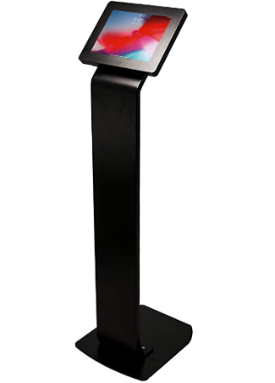  (see below for photo reference) | 6 pcs. |  | Color: Black  Material: Alloy Steel / Durable Steel Body  Heavy-duty locking enclosure  Enclosure rotates 360°, Easily adjusting for horizontal and vertical views  Provides full access to camera, home button and charging socket  Fits iPad-2019 (7th generation) 10.2 inch  Provision for charging station and wiring organization if there will be a need to charge inside the Pavilion’s exhibit spaces  Height may be adjustable depending on the recommendation of supplier | 2 pcs at Area 2A- Nature is Peace  2 pcs at Area 2B- Man is Nature  2 pc at Variety of the World  2 pcs. at the Our Gift to the World
 |  | 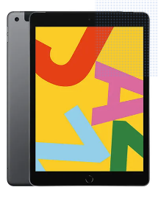  iPad-2019 | 6 pcs. |  | iPad-2019 (7th Generation) 10.2inch, 64GB, Wi-Fi, Space Gray/ Black  Complete with Charger with applicable wiring and accessories  Display Resolution: 2160x1620 pixel  For Rental | -do-
 |  | 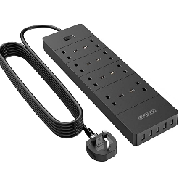  2-3 Meter Extension Cord | 4 pcs. |  | 2-3 Meter Extension Cord  3250W Power Strip,  1700J Surge Protector  Extension Lead with 4 AC socket, 13amp Fused UK Plug | -do-
- All specifications provided must be followed by the suppliers or approved equivalent must be submitted before commencing and installation
- All items are on rental basis
- Stage and Audience
 |  | Item |  | Qty | Description | Locations | Statement of compliance
 |  | Movable Stage Platform/ Stage System  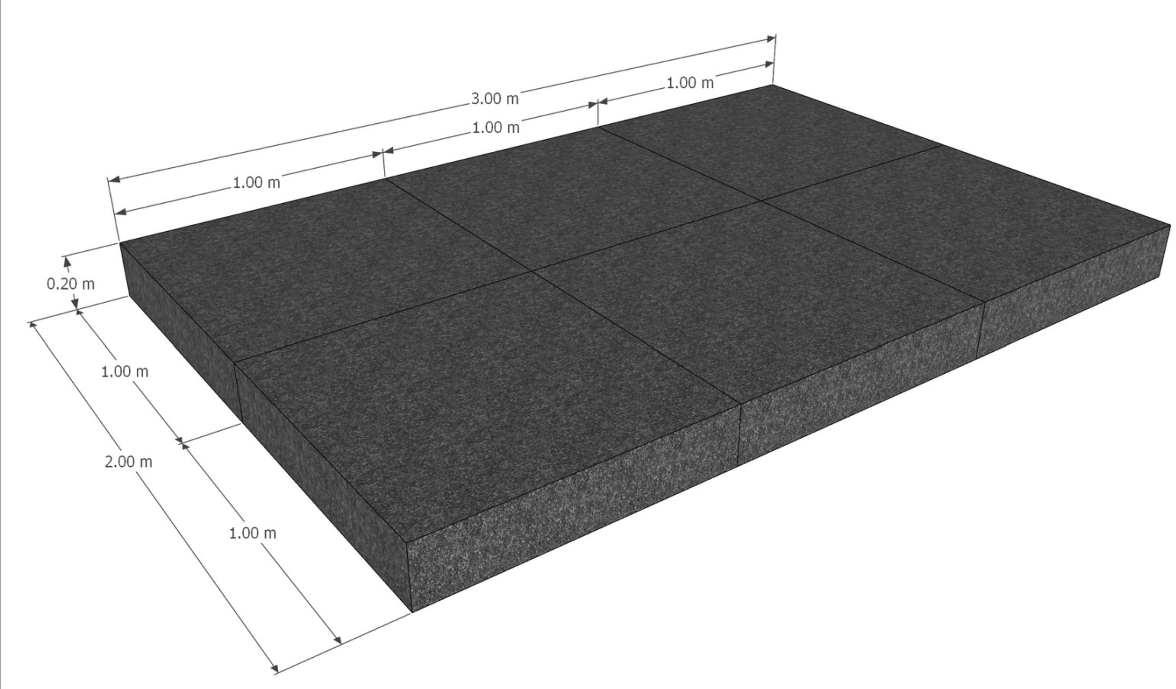 |  | 1 lot | Size: 1.0 x 1.0 m  Height: .2 m  Surface: weatherproof 12 mm blockboard with HEXA anti-slip coating  - Dimensions: 1.0 x 1.0 m  Max. Load capacity: 250 kg at 1.0 x 0.5 m  - Weight: 8 kg (without feet)  - Surface colour: black  Should include folding leg for stage platforms with click function  With heavy-duty caster wheels with lock | - Imaginarium Decks (Deck 1, Deck 2, Roofdeck)
 |  | Workshop Tables  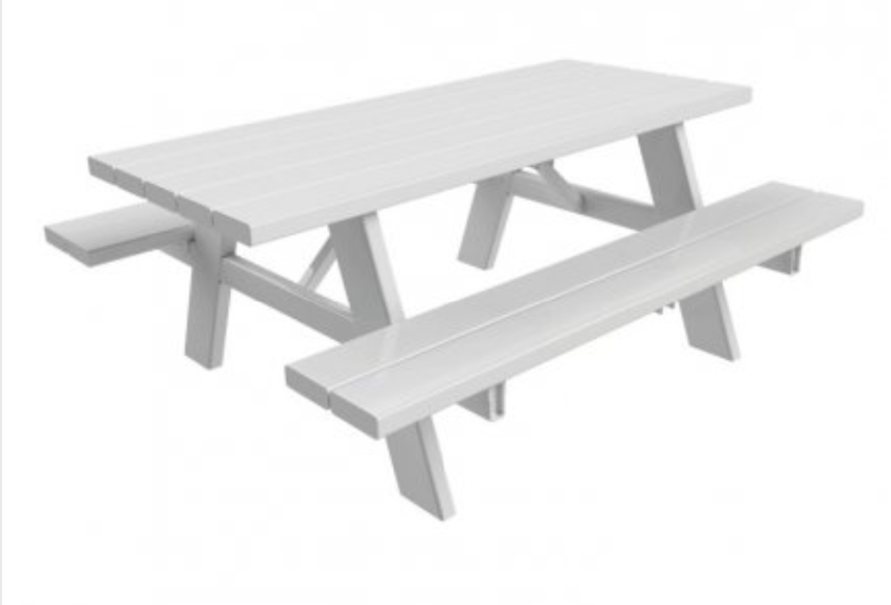 |  | 4 pcs. | Custom made 3 pc wooden picnic table for outdoor use - collapsible  Can be used for indoor and outdoor set-up  Table Size (in cm):  85x150x75 (WxLxH)  Bench Size (in cm):  30x150x44 (WxLxH) | -do-
 |  | 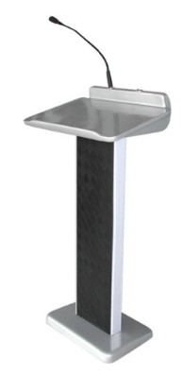  Rostrum |  | 1 pc. | Rostrum  Refer to sample photo  Subject to proposal of bidder | -do-
- All specifications provided must be followed by the suppliers or approved equivalent must be submitted before commencing and installation
- All items are on rental basis

6. | PERIOD COVERED
Delivery Date: November 23, 2021
Rental Date: until 31 December 2021
7. | BUDGET AND TERMS OF PAYMENT
 | Approved budget for the contract (ABC) is AED 55,000 or PHP 770,000.00 inclusive of all applicable taxes in the UAE upon delivery of completed requirement. The winning bid shall be determined based on the quality of proposal with the most advantageous financial package cost, provided that the amount of bid does not exceed the ABC.
 | Invoices and Payments must be issued/ payable to the Republic of the Philippines Pavilion –Expo 2020 with license no. EXP-01-46.
Payment schedule will be every 25th of the month from November 2021 to December 2021 as follows:
50% of Contract Price - November 25
50% of Contract Price -December 25

 | Payment will be processed upon receipt of the invoice/ request for payment from the winning bidder after services have been rendered. All payments shall be subject to applicable Philippine government laws and regulations.

I hereby certify that the statement of compliance to the foregoing technical specifications are true and correct, otherwise, if found to be false either during bid evaluation or post-qualifications, the same shall give rise to automatic disqualification of our bid.

Name of Company:
Signature:
Signature Over Printed Name of Authorized Representative
Date:

Conforme:

______________________________________
Name & Signature of Authorized Representative

__________________________
Date signed

