Section VI. Schedule of Requirements
For Overseas Procurement – Provision, Installation and Set-Up of Public Address and Projection System for the Pocket Events at the Philippines Pavilion at Expo 2020 Dubai

The delivery schedule expressed as weeks/months stipulates hereafter as date of delivery to the project site.

Item Number | Requirements | Quantity | Delivered, Weeks/Months | Statement of Compliance
Period: November to December 31, 2021

- Public Address and Projection System for Pocket Events
 | Item | Qty | Description | Delivered, Weeks/ Months | Statement of Compliance
 | Portable Public Access (PA) System  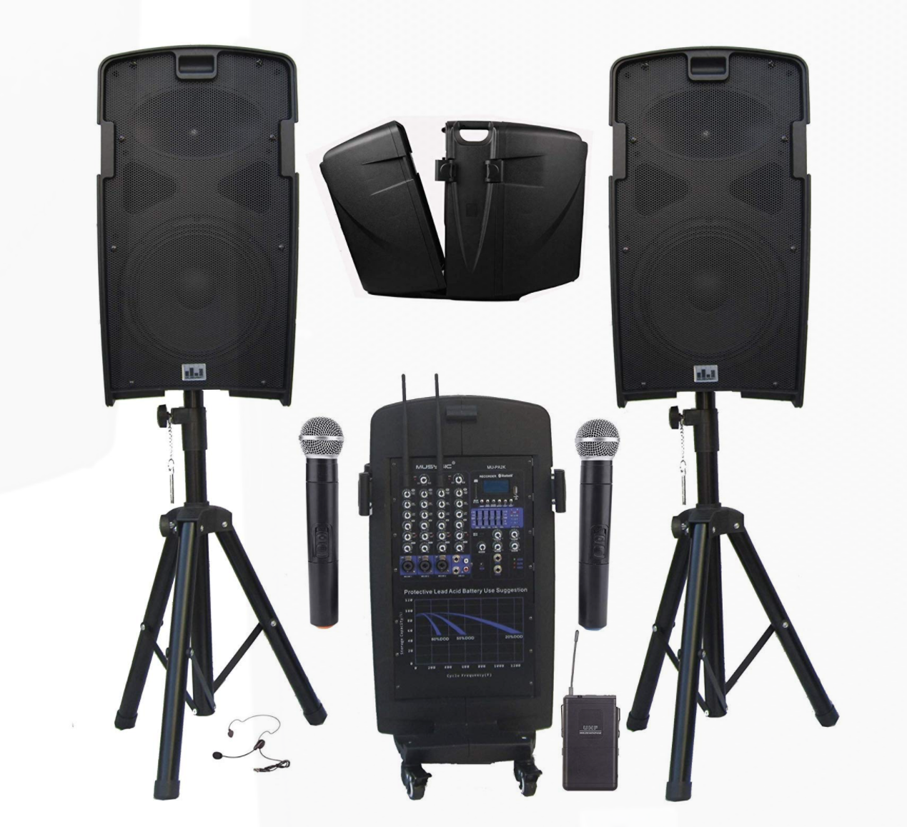 | 1 set | - Professional 2000 Watts Portable PA System  - 5 Channel Mixer with Built-in Class-D Amplifier  - Built-in Dual UHF Wireless Microphone System, Rechargeable Battery, Cables & Speaker Stands.  - 2000 watts PMPO - ample for medium to large audiences / Integrated 5-channel mixer lets you intuitively mix lecture panels, musical ensembles and more /.  - Bluetooth Function, USB/SD Card Slot (Record, Play/Pause, Previous Track, Next Track)  - Built-in Rechargeable Battery (4-5 hours of uninterrupted sound on full charge), Speaker stands, Wheels for easy moving.  - Rechargeable battery- great for both  indoor/outdoor events when there is no external power source  available (tested to provide 4-5 hours of uninterrupted sound on  full charge). System work with Plug-in power cord and also with  Rechargeable battery  - With simple and easy setup/breakdown process of the system and allows  for easy transportation
 | Microphone Stands  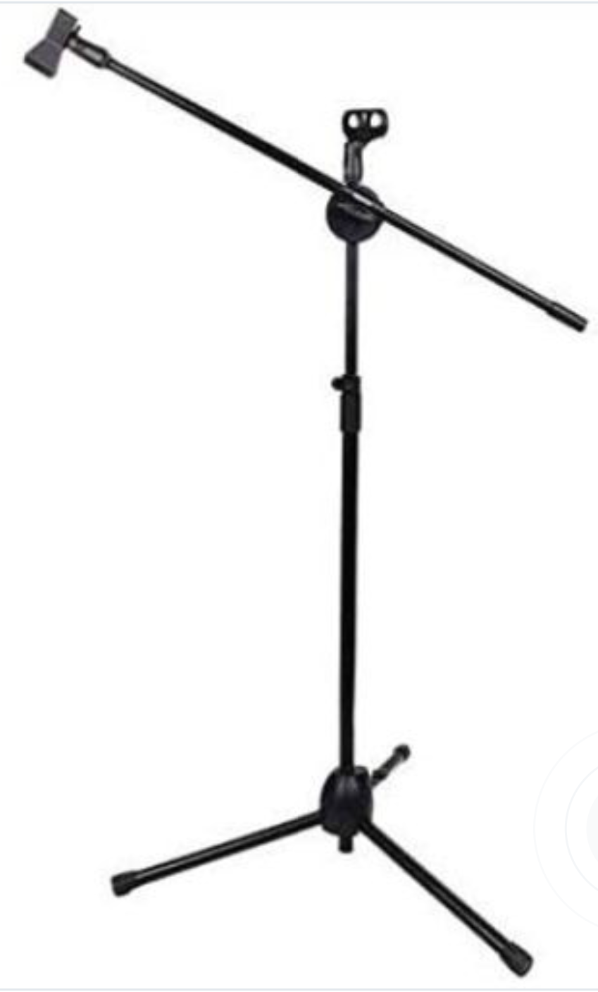 | 4 pcs | - Metallic Tripods Holder Telescopic Floor Boom Stand  - Powder-Coated finish and scratch resistant
 | Pro Portable Projector for Outdoor  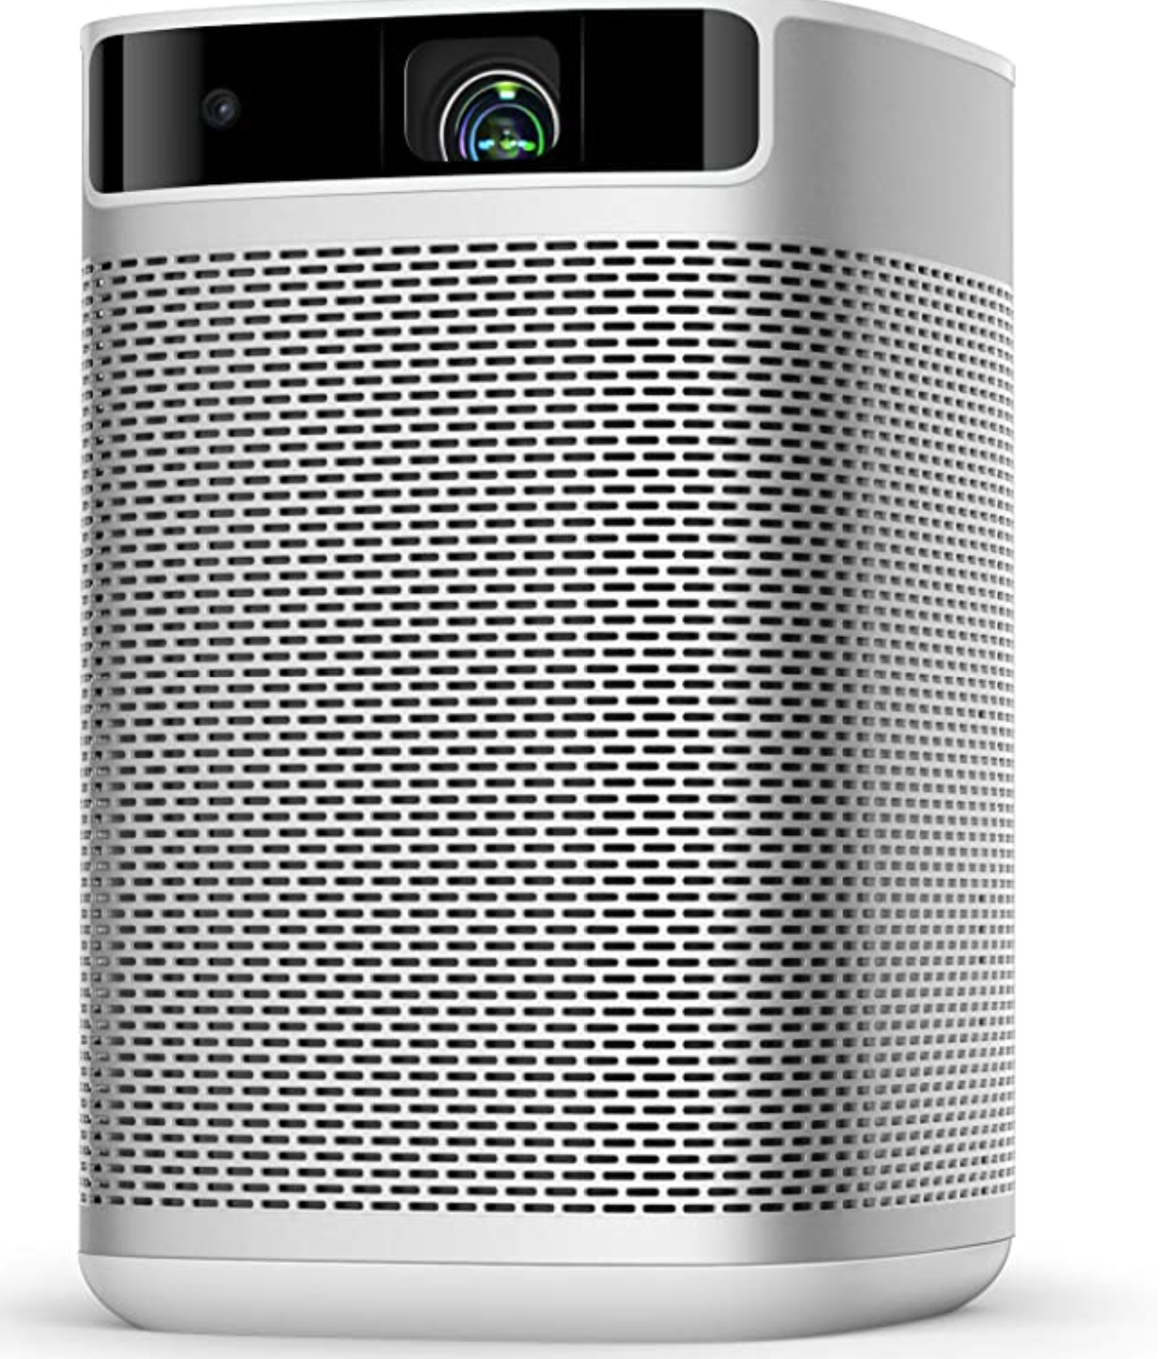 | 1 pc | - Pro Portable Projector for Outdoor projection  - 1080 P Image with 300 ANSI Lumens  - Smart Projector with Keystone Correction  - WiFi Bluetooth  - Android TV 9.0 5000  - With HDMI port, USB 2.0 ports  - Battery powered  - Average Battery Life (> 3.5 hrs)
 | Projection Screen  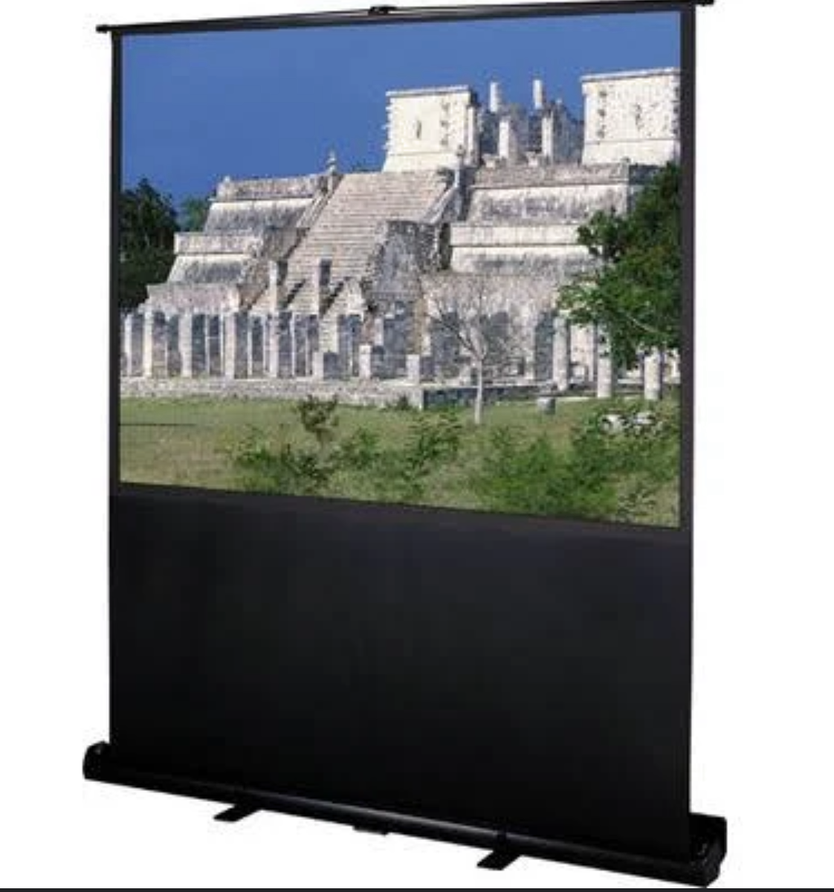 | 1 pc | Theatre portable projection screen (100 inch)  Tension Control: Pneumatic scissor mechanism – easily raise and lower the screen
 | Portable Power Source  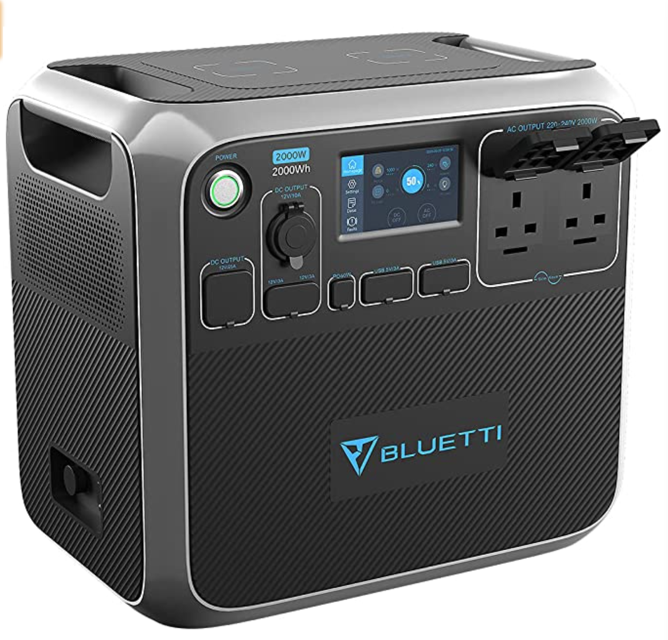 | 1 pc | - Portable Power Generator 2000Wh  - Solar Power Station Lithium Battery Power Supply with LED Flashlights  - Weight: 3.06 kg  - A wide range of output options:  - 2*AC outlets, 1*12V/25A RV port, 2*15W wireless pad, 1* PD 60W USB-C, 4* USB-A, 1*12V/10A car port and 2* 12V/3A  - With built-in advanced system control circuit module
 | Laptop Audio Connection  Cables and Accessories | 1 set
- All specifications provided must be followed by the suppliers or approved equivalent must be submitted before commencing and installation
- All items are on rental basis

Conforme:
______________________________________
Name & Signature of Authorized Representative
__________________________
Date signed

