Section VII. Technical Specifications
Technical Specifications

Specification | Statement of Compliance
STATE THE COMPLETE TECHNICAL SPECIFICATIONS | [Bidders must state here either “Comply” or “Not Comply” against each of the individual parameters of each Specification stating the corresponding performance parameter of the services and equipment offered. Statements of “Comply” or “Not Comply” must be supported by evidence in a Bidders Bid and cross-referenced to that evidence. Evidence shall be in the form of manufacturer’s un-amended sales literature, unconditional statements of specification and compliance issued by the manufacturer, samples, independent test data etc., as appropriate. A statement that is not supported by evidence or is subsequently found to be contradicted by the evidence presented will render the Bid under evaluation liable for rejection. A statement either in the Bidder's statement of compliance or the supporting evidence that is found to be false either during Bid evaluation, post-qualification or the execution of the Contract may be regarded as fraudulent and render the Bidder or supplier liable for prosecution subject to the applicable laws and issuances.]

For Overseas Procurement – Provision, Installation and Set-Up of Public Address and Projection System for the Pocket Events at the Philippines Pavilion at Expo 2020 Dubai
TECHNICAL SPECIFICATIONS

INSTRUCTIONS TO THE BIDDER: Indicate “COMPLY” per line number under Bidder’s Statement of Compliance if Bidder can meet the technical specifications and project requirements. DO NOT LEAVE ANY BLANK. A “YES” or “NO” ENTRY WILL NOT BE ACCEPTED. FAILURE TO CONFORM WILL RESULT IN A RATING OF “FAILED”.

# | MINIMUM SPECIFICATIONS | Statement of compliance
1. | Background/ Objective for services being procured
Background:
The Philippines Participation in Expo 2020 Dubai has generated over 100,000 visitors for its first month of its operations and is expecting an increase in visitors by both foreign and local based in Dubai, due to the incoming winter season and the easing of travel restrictions worldwide.

The Philippines Expo Secretariat conducted market scanning and initiated group discussions with avid visitors, vloggers/bloggers and content strategists to talk about actionable improvements that can be done in the Pavilion.

As a result of these consultative meetings, the Philippines Pavilion Secretariat decided to stage more pocket events to enliven the Pavilion grounds and provide frequent entertainment to visitors.

Therefore, there is a need to conduct overseas procurement for the provision of a public address and projection system at the Philippines Pavilion at Expo 2020 Dubai.

Objective:
- To enliven the outdoor spaces of the Philippines Pavilion and provide entertainment to both local and foreign visitors
- To increase visitor engagement through the staging of pocket events at the Philippines Pavilion

2. | ELIGIBILITY REQUIREMENTS
- VAT Registration in UAE
- Company Profile
- Business License to Operate in the UAE
- Tax Clearance (or its equivalent in UAE)

3. | TECHNICAL SPECIFICATIONS/ SCOPE OF WORK
 | Bidders for this overseas procurement request must be based in Dubai, United Arab Emirates and can deliver the requirements on urgent basis following the Philippine Government Procurement rules and regulations or per RA 9184.
 | The Bidder will provide, set-up and install the following equipment on lease from the date of awarding until 31 December 2021;
 | The Bidder would provide the basic maintenance and services to the equipment at no extra cost as and when required by Client;
 | Spare parts will be provided without additional cost to the Client during the rental period;
 | The rental agreement may be terminated by either parties provided a 30-day written notice was sent to and accepted by other party.

 | Item | Qty | Description | Statement of compliance
 | Portable Public Access (PA) System  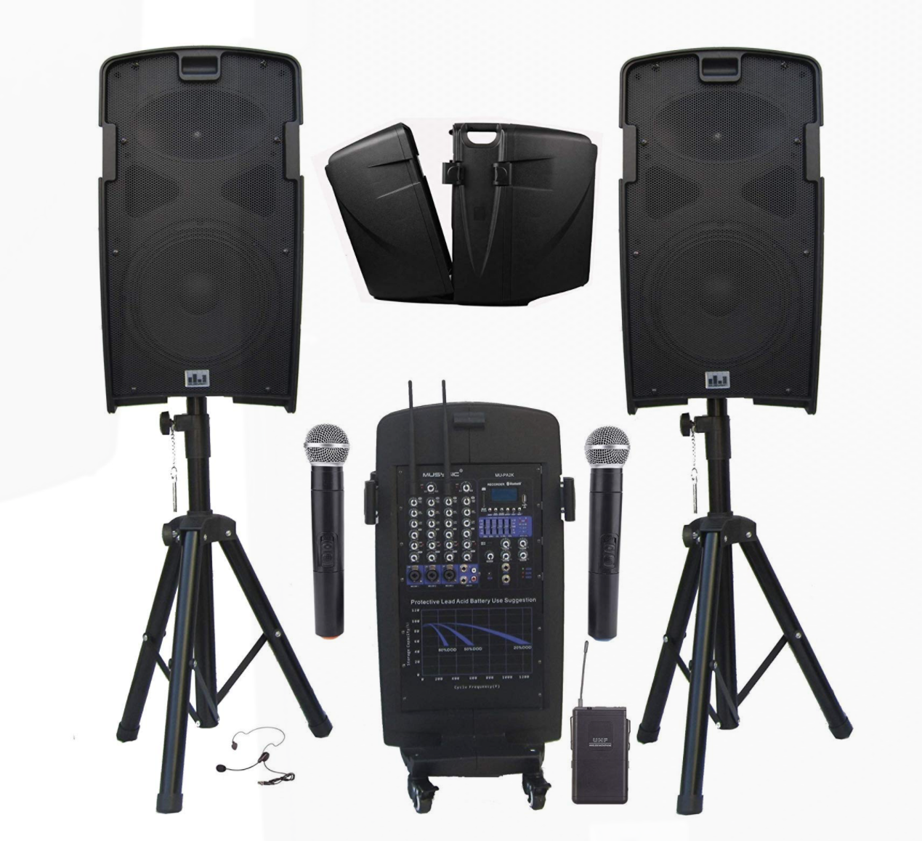 | 1 set | - Professional 2000 Watts Portable PA System  - 5 Channel Mixer with Built-in Class-D Amplifier  - Built-in Dual UHF Wireless Microphone System, Rechargeable Battery, Cables & Speaker Stands.  - 2000 watts PMPO - ample for medium to large audiences / Integrated 5-channel mixer lets you intuitively mix lecture panels, musical ensembles and more /.  - Bluetooth Function, USB/SD Card Slot (Record, Play/Pause, Previous Track, Next Track)  - Built-in Rechargeable Battery (4-5 hours of uninterrupted sound on full charge), Speaker stands, Wheels for easy moving.  - Rechargeable battery- great for both  indoor/outdoor events when there is no external power source  available (tested to provide 4-5 hours of uninterrupted sound on  full charge). System work with Plug-in power cord and also with  Rechargeable battery  - With simple and easy setup/breakdown process of the system and allows  for easy transportation
 | Microphone Stands  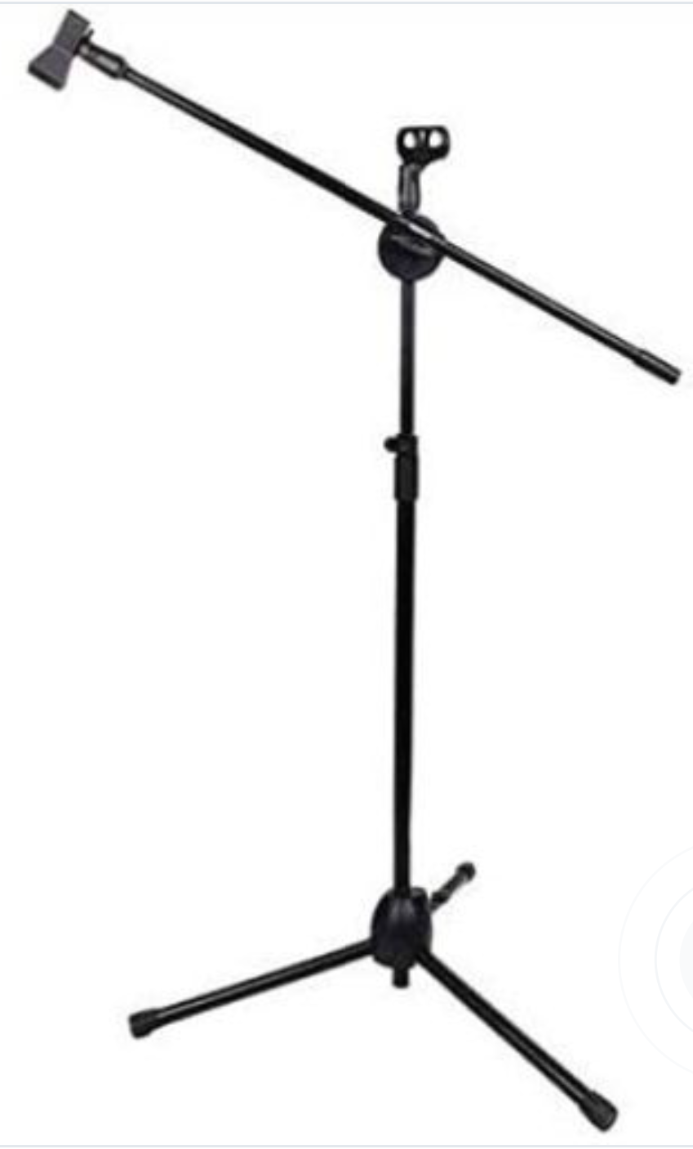 | 4 pcs | - Metallic Tripods Holder Telescopic Floor Boom Stand  - Powder-Coated finish and scratch resistant
 | Pro Portable Projector for Outdoor  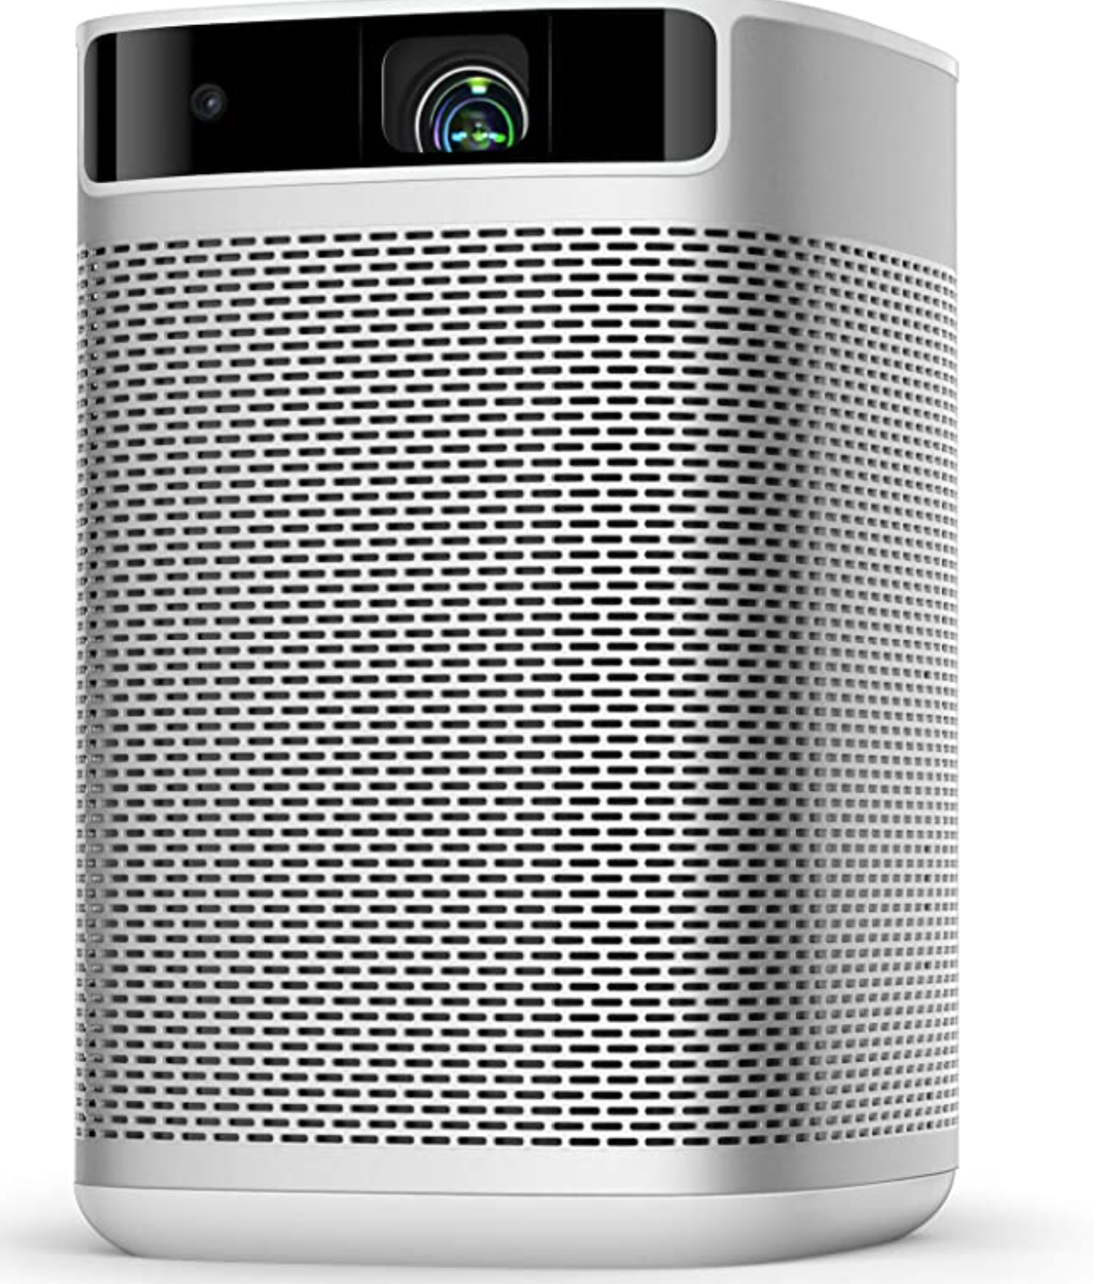 | 1 pc | - Pro Portable Projector for Outdoor projection  - 1080 P Image with 300 ANSI Lumens  - Smart Projector with Keystone Correction  - WiFi Bluetooth  - Android TV 9.0 5000  - With HDMI port, USB 2.0 ports  - Battery powered  - Average Battery Life (> 3.5 hrs)\
 | Projection Screen  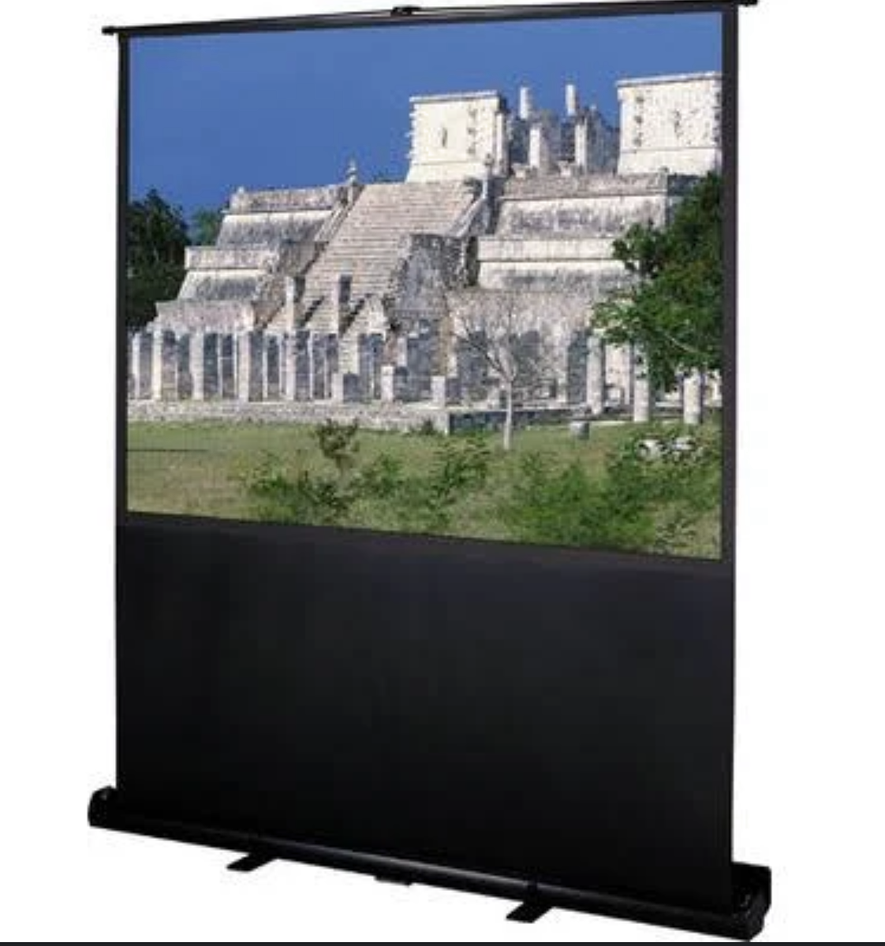 | 1 pc | Theatre portable projection screen (100 inch)  Tension Control: Pneumatic scissor mechanism – easily raise and lower the screen |  | COMPLY
 | Portable Power Source  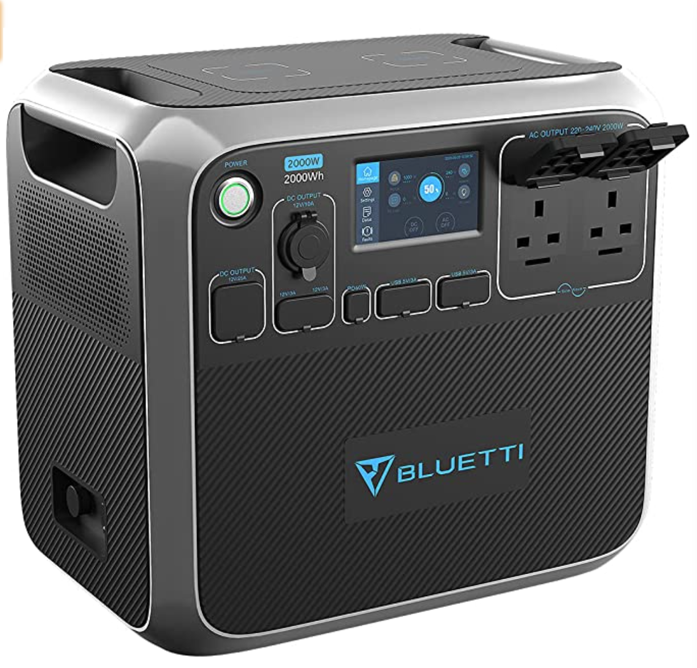 | 1 pc | - Portable Power Generator 2000Wh  - Solar Power Station Lithium Battery Power Supply with LED Flashlights  - Weight: 3.06 kg  - A wide range of output options:  - 2*AC outlets, 1*12V/25A RV port, 2*15W wireless pad, 1* PD 60W USB-C, 4* USB-A, 1*12V/10A car port and 2* 12V/3A  - With built-in advanced system control circuit module
 | Laptop Audio Connection  Cables and Accessories | 1 set
- All specifications provided must be followed by the suppliers or approved equivalent must be submitted before commencing and installation
- All items are on rental basis

4. | PERIOD COVERED
Delivery Date: November 20-23, 2021
Contract Period: until December 31, 2021
5. | BUDGET AND TERMS OF PAYMENT
 | Approved budget for the contract (ABC) is AED 25,000 or PHP 350,000.00 inclusive of all applicable taxes in the UAE upon delivery of completed requirement. The winning bid shall be determined based on the quality of proposal with the most advantageous financial package cost, provided that the amount of bid does not exceed the ABC.
 | Invoices and Payments must be issued/ payable to the Republic of the Philippines Pavilion –Expo 2020 with license no. EXP-01-46.
 | Payment schedule will be every 25th of the month from November 2021 to December 2021
 | Payment will be processed upon receipt of the invoice/ request for payment from the winning bidder after services have been rendered. All payments shall be subject to applicable Philippine government laws and regulations.

I hereby certify that the statement of compliance to the foregoing technical specifications are true and correct, otherwise, if found to be false either during bid evaluation or post-qualifications, the same shall give rise to automatic disqualification of our bid.

Name of Company:
Signature:
Signature Over Printed Name of Authorized Representative
Date:

Conforme:

______________________________________
Name & Signature of Authorized Representative

__________________________
Date signed

